# THESIS

OCCURRENCE, DISTRIBUTION, AND DRIVING ENVIRONMENTAL FACTORS OF QUAKING ASPEN REGENERATION BY SEED IN THE CAMERON PEAK FIRE BURN SCAR

Submitted by

Sarah Carter

Department of Forest and Rangeland Stewardship

In partial fulfillment of the requirements

For the Degree of Master of Science

Colorado State University

Fort Collins, Colorado

Spring 2024

Master’s Committee:

Advisor: Sarah Hart

Charles Rhoades

Monique Rocca

# 

# 

# 

# 

# 

# 

# 

# 

# 

# 

# Copyright by Sarah Carter 2024

All Rights Reserved

ABSTRACT

Occurrence, distribution, and driving environmental factors of quaking aspen regeneration by seed in the cameron peak fire burn scar

As a result of the increasing frequency and severity of wildfires in the mountain west region of North America, greater mortality of montane and subalpine forests has led to changes in forest regeneration patterns and species composition. Increased drought conditions pre- and post-fire due to warming climate and destruction of existing seed have led to loss of historically conifer-dominant forests. This has subsequently opened a niche for post-fire aspen establishment, particularly through seed. The understanding of aspen regeneration by seed is understudied in comparison to the more broadly emphasized vegetative reproduction: a process which is limited spatially by the presence of surviving root networks and a lack of adaptive capacity of clone genetics. In this study, we aimed to (1) quantify the presence and density of post-fire aspen seedling establishment and (2) assess the environmental drivers of post-fire seedling establishment in a recent burn scar in northern Colorado. Two growing seasons following the fire, we conducted field surveys at 38 sites within the Cameron Peak Fire burn scar. We aimed to quantify regeneration of all tree species, including aspen as well as the dominant pre-fire conifers ponderosa pine (*Pinus ponderosa*), lodgepole pine (*Pinus contorta*), subalpine fir (*Abies lasiocarpa*), and Engelmann spruce (*Picea engelmannii*). Across our study area we found widespread establishment of aspen seedlings, particularly at high elevations, where soil moisture is less limiting. Given the occurrence of aspen seedlings within a site, we found seedlings were most likely to occur in moss seedbeds, near large coarse woody debris, and within microsite concavities, where soil moisture availability is likely higher. Collectively, our findings highlight the importance of moisture availability for the germination and initial survival of aspen seedlings. Further we found occurrence of aspen seedlings far outweighed that of any conifer species. These findings support projected changes in forest composition, species dominance, and range shift following stand replacing fire to favor early successional species such as aspen. The successful dispersal and establishment of aspen seeds in large, high severity burned patches have potential to facilitate the range shift of aspen forests towards higher elevations.These implications become more prevalent as changes in climate increase the risk of high severity fires and loss of seed sources, while decreasing suitability for montane and subalpine forest species to persist and regenerate.

ACKNOWLEDGEMENTS

A huge thank you to my advisor, Sarah Hart and my committee, Chuck Rhoades and Monique Rocca for supporting and mentoring me through this project. In particular, Dr. Rhoades for allowing me to store 500 seedlings on his family property. Dr. Hart has also been an incredible source of expertise, guidance, and resources at every stage of this project. I would also like to thank my coaches Kelly Hart, John Elders, and Jim Nagel for dealing with my often hectic athletic and academic schedule. A huge thank you to my technicians Preston Young and Samantha Maldonado for spending long and difficult hours in the field with me. I am so appreciative of my lab members, friends, and family for their support and encouragement through the completion of my academic career.

# 

TABLE OF CONTENTS

**THESIS 1**

**Copyright by Sarah Carter 2024 2**

Introduction 1

Quaking aspen background 2

Aspen reproduction 3

Known conditions for seedling regeneration 4

Fire and aspen regeneration 5

Drivers of post-fire seedling establishment 6

Objectives 7

Methods 7

Study area 7

Site selection 9

Plot design 12

Field data collection 12

Aspen seedling and overall regeneration survey 12

Data analysis 13

Site-level drivers of seedling occurrence, density, subplot stocking, and height 13

Microsite drivers of seedling occurrence 14

Results 15

Patterns of subplot stocking 18

Discussion 22

References 31

Appendix 36

Identification of aspen seedlings 36

# 

# Introduction

In recent decades, a widespread increase in frequency, severity, and extent of forest disturbance, including wildfire in Western North America, has occurred as a result of climate change (Carlson et al., 2020). Survival and regeneration of montane and subalpine forest following fire is heavily dependent on both the persistence of living trees and species-specific abilities to germinate, survive and persist in increasingly hotter and drier conditions (Davis et al. 2019). Serotinous and fire-adapted species, such as lodgepole pine, fare better than other high elevation conifers, however the total destruction of seeds within high severity burn zones severely limits regeneration (Carlson et al., 2020). A lack of conifer regeneration potential subsequently opens a competitive niche favoring early successional species with a high range of seed dispersal, as well as non-tree vegetation. Effects of climate change alone have been shown to be significant enough to alter the composition and distribution of species following stand-replacing fire (Hurteau et al., 2014). This has facilitated changes to landscape composition and even shifts in species’ distributions (Nigro et al. 2022).

Due to severity of burn coupled with unsuitable climatic and habitat conditions, conifer regeneration has reduced, in some cases leading to a total shift in ecosystem type (Stevens-Rumann et al., 2018). This is a particular risk for dry forests already existing on the edge of climatically suitable zones (Stevens-Rumann et al., 2018). Tree species dependent on cooler and wetter conditions for establishment are gradually shifting upwards along an elevational gradient to track suitable habitat conditions, however the capacity of plants to alter ranges occurs at a much slower rate than the change of climatic conditions and disturbance regimes (Hill & Field, 2021). High severity wildfire may help or hinder range shifts depending on a species’ morphology and dispersal patterns, as well as habitat needs (Hill & Field, 2021). For instance, a stand replacing wildfire may remove a competitive barrier to range expansion beyond historical borders, a process that is particularly advantageous to early successional species, such as quaking aspen (Krasnow & Stephens, 2015, Nigro et al., 2022).

## Quaking aspen background

Across North America, quaking aspen (*Populus tremuloides*) is one of the most widely spread early successional species, where it plays a key role in post-fire forest recovery and makes significant contributions to biodiversity, forage sources for wildlife and livestock, and aesthetics (Crouch et al., 2023, Howe et al., 2020, Krasnow & Stephens, 2015). Despite being the most widespread tree species in North America, aspen has been in a general state of decline in the west for several decades due to a lack of resilience and adaptive capacity for changing climatic conditions (Crouch et al., 2023, Howe et al., 2020). Contributing stressors to aspen decline include drought, pathogens, conifer encroachment, herbivory, and conifer-favoring forest management practices, all of which leave surviving colony members at greater vulnerability to future adverse conditions (Krasnow & Stephens, 2015, Worrall et al. 2010; Singer et al. 2019). Climate models predict both range contraction and shift of aspen throughout the mountain west in future decades (Howe et al., 2020).

Many of these issues are also exacerbated by the limitations of aspen’s primary means of reproduction, which occurs vegetatively through root suckering, the focus of most aspen-based management practices (Howe et al., 2020). Dependence on asexual root suckering may hamper genetic diversity, range expansion, and adaptive capacity of the species, as clonal colonies possess identical genetic information to the first parent tree of the colony (Krasnow & Stephens, 2015). Currently, the majority of aspen-related forest management is practiced for the benefit of vegetative regeneration potential, limiting both the geographical range of management and methods utilized (Howe et al., 2020). Managing exclusively for vegetative reproduction may lead to the stagnation or decline of aspen genetic diversity, as well as limitation of adaptive evolution and unintended favoring of triploid aspen (Howe et al., 2020). While common in the western United States, triploid aspen may not be beneficial for the future success of the species, as they are more susceptible to hydraulic failure under drought conditions and reduced fertility (Howe et al., 2020). As a whole, aspen are dependent on rapid colonization following disturbance, providing greater resource access for suckers and saplings and long term persistence of colonies (Krasnow & Stephens, 2015, Howe et al., 2020).

## Aspen reproduction

The assumption of asexual or vegetative reproduction through root suckering as the only significant means of quaking aspen regeneration is a common misconception that has pervaded historical research and perception of aspen as a species (Krasnow & Stephens, 2015). When aspen have the capacity to spread via root suckering, they do so prolifically, and it is often assumed that any young aspen present on a landscape is a result of vegetative sprouting (Reitschmiedov´a et al., 2022). However, the formation of root suckers is limited by availability of viable roots, many of which may host multiple root suckers, and maturity of potential parent trees (Reitschmiedov´a et al., 2022). Reitschmiedov´a et al. found that unlike other vegetatively reproducing species (*Salix caprea*, *Betula pendula*), the majority of aspen root suckers originate from a mature parent tree rather than seedlings or young trees that established from seed. Root suckers establish predominantly in high density, localized clonal patches, but long distance seed dispersal in lower quantities is not unheard of (Reitschmiedov´a et al., 2022). Novel research over the past decade has suggested that sexual reproduction is more common than historically thought (Krasnow & Stephens, 2015, Kreider & Yocom, 2021).

Historically, arid conditions in the western United States have been thought to generally preclude aspen seedling germination and establishment, with further limitations of fire suppression and ungulate herbivory (Fairweather et al., 2014, Howe et al., 2020, Kreider & Yocom, 2021). Reproduction by seed may be critical for the successful long term survival of aspen in the West, both through the increase of genetic diversity and establishment of new clonal populations in historically non-aspen stands (Quinn & Wu, 2001). Aspen seeds are small in size and wind dispersed, capable of reaching up to and beyond 10,000 m from the parent tree (Kreider & Yocom, 2021). This may allow for establishment on new sites not populated by aspen. This also promotes increased success of seedling recruitment, as in close proximity to parent trees, aspen seedlings are often outcompeted by root suckers in the first two years following germination (Kreider & Yocom, 2021). Seedling establishment in regions near the edge of traditional aspen range could also aid in increasing the flexibility of the species to tolerate long term survival in novel conditions (Quinn & Wu, 2001).

## Known conditions for seedling regeneration

Aspen seedlings are especially vulnerable to drought in the first season following germination and require consistently moist soil for survival (Quinn & Wu, 2001, Reitschmiedov´a et al., 2022). This is a potential limitation to the successful distribution of aspen seedlings, as germination decreases with lower percentages of soil moisture (Kreider & Yocom, 2021). However, there is no evidence to suggest that aspen seedling establishment is unable to occur in drier years (Kreider & Yocom, 2021). On a smaller scale, microsite conditions including soil disturbance, presence of shelter material, and microtopography have been shown to be influential on seedling establishment patterns (Kreider & Yocom, 2021). Rough and loosely packed substrate surfaces are beneficial for the trapping of lightweight, wind dispersed seeds and may aid in establishment (Reitschmiedov´a et al., 2022). As a pioneer species, aspen seedlings are also highly dependent on availability of light. Aspen seedlings are acutely responsive to competition, especially among their own species and in conjunction with pine. In a greenhouse study, aspen grew significantly taller when planted with a pine seedling (*Pinus ponderosa*) compared to growth with another aspen seedling, narrowleaf cottonwood (*Populus angustifolia*), or alone (Kerr et al., 2021). Growth was most stunted when aspen seedlings were presented with competition from the same species and other deciduous species (*Populus angustifolia*) (Kerr et al., 2021). This suggests that aspen seedlings have potential to thrive when establishing in a conifer-dominant stand with pine regeneration present, but may be easily outcompeted by other aspen, both root suckers and seedlings. Consistent ground cover in the form of litter and/or herbaceous vegetation also reduces the suitability of microsite conditions for pioneer species seedling establishment (Reitschmiedov´a et al., 2022).

## Fire and aspen regeneration

Due to their ability to disperse over long distances and preference for heavily disturbed, low competition site conditions, aspen seedlings may be the most successful pathway for forest regeneration in high severity burn scars (Kreider & Yocom, 2021). Fires that burn for multiple weeks over variable topography and conditions may produce a heterogenous burn pattern and microsite conditions that are conducive to the establishment of aspen by seed (Kreider & Yocom, 2021, Quinn & Wu, 2001). While these more intense and uncontrolled burns have negative social, economic, and ecological impacts, they also create an open canopy and bare mineral soil conditions that contribute to the successful germination of seedlings, whereas less intense burns are more likely to result in dominance of vegetative aspen regeneration (Quinn & Wu, 2001). Greater instances of high severity fire may provide suitable sunlight, bare mineral soil, and lack of competition necessary for the successful germination and establishment of aspen seedlings. The covering of surface soil by litter and organic matter reduces the seed-based establishment of pioneer species, including aspen (Reitschmiedov´a et al., 2022).

This has become increasingly important following high severity fire at sites historically dominated by non-pioneer conifer species, especially in circumstances where much or all of the existing seed has been destroyed through burning or pre-fire beetle kill (Rhoades et al., 2022). In particular, beetle activity in lodgepole dominant forests may lead to long term losses in seed availability and viability (Nigro et al., 2022, Rhoades et a., 2022). Furthermore, existing aspen colonies are primarily made up of a clonal network sharing identical genetic information with the original parent tree, which may be decades to centuries old. Clonal colonies are unable to expand beyond the current expanse of the root network, limiting opportunities for range expansion of existing aspen stands (Krasnow & Stephens, 2015). While environmental conditions and aspen phenotypes may have been well-suited for one another at the time of original germination, changes in climate, disturbance regime, and surrounding forest structure may render the site non-optimal for aspen persistence (Krasnow & Stephens, 2015).

## Drivers of post-fire seedling establishment

Earlier studies have connected post-fire seedling establishment with factors such as percent burned, slope, canopy cover, sucker density, seed-source distance, aspect, and annual precipitation (Kreider & Yocom, 2021 a, Kreider & Yocom, 2021 b). Regional annual precipitation has been shown to be the most significant environmental factor in seedling mortality, based on research conducted across 15 fires in the mountain west region of the United States (Kreider & Yocom, 2021). These findings supported aspen seedling reliance on consistent access to moisture for germination and first-year survival. However, while seedling establishment increased at higher elevations, where there is generally less moisture limitation, and with higher annual precipitation rates, early survival was greater at low elevation sites (Kreider & Yocom, 2021). Further study by Kreider & Yocom (2021) determined that aspen seedlings established preferentially in concave microsites and on burned soils (Kreider & Yocom, 2021 B). Sucker density has also been observed to decrease the probability of aspen seedling occurrence, growth, and survivorship.

## Objectives

In this study, our overarching aim is to understand patterns of aspen establishment from seed in a recent fire in northern Colorado. Specifically, we ask the following:

1. Has aspen regeneration by seed occurred within two years following the burn?
2. If so, where are aspen seedlings establishing?
3. What environmental and microsite conditions contribute to the occurrence and frequency of seedling establishment?

We hypothesize: (A) seedlings will be more likely to occur when mature aspen are not locally present, as seedlings are likely to be outcompeted by root suckers (Kreider & Yocom, 2021); (B) seedling occurrence and density will be greater at higher elevations where soil moisture is less limiting (Kreider & Yocom, 2021); and (C) microtopography will influence the accumulation of seedlings, as concave microsite conditions will serve as a collection point for both wind dispersed seeds and essential resources including water (Kreider & Yocom, 2021).

# Methods

## Study area

We surveyed aspen seedling regeneration across forests that burned in the 2020 Cameron Peak Fire located in Roosevelt National Forest, northern central Colorado (Fig. 1). The Cameron Peak Fire was the largest wildfire in Colorado history, with a total burn area of over 84,544 hectares and approximately five months of burn time from August - December of 2020 (Swayze et al., 2021). The study area spans an elevation gradient from 2519 m to 3259 m and is characterized by a continental climate. However, the two spring periods following the fire were notably high in precipitation, improving growing season conditions for seedling establishment and survival in their most vulnerable stage (Swayze et al., 2021).

Pre-fire forest composition and structure within the Cameron Peak burn scar varied with elevation. Lower elevation zones below 2800 m were characterized by dry and mesic montane forests, dominated by ponderosa pine (*Pinus ponderosa*), with lesser components of Douglas-fir (*Pseudotsuga menziesii*). Moderate and higher elevation stands between approximately 2800 – 3300 m were made up of mixed conifer subalpine forest, dominated by Engelmann spruce (*Picea engelmannii*), subalpine fir (*Abies lasiocarpa*), and lodgepole pine (*Pinus contorta*). (Swayze et al., 2021).

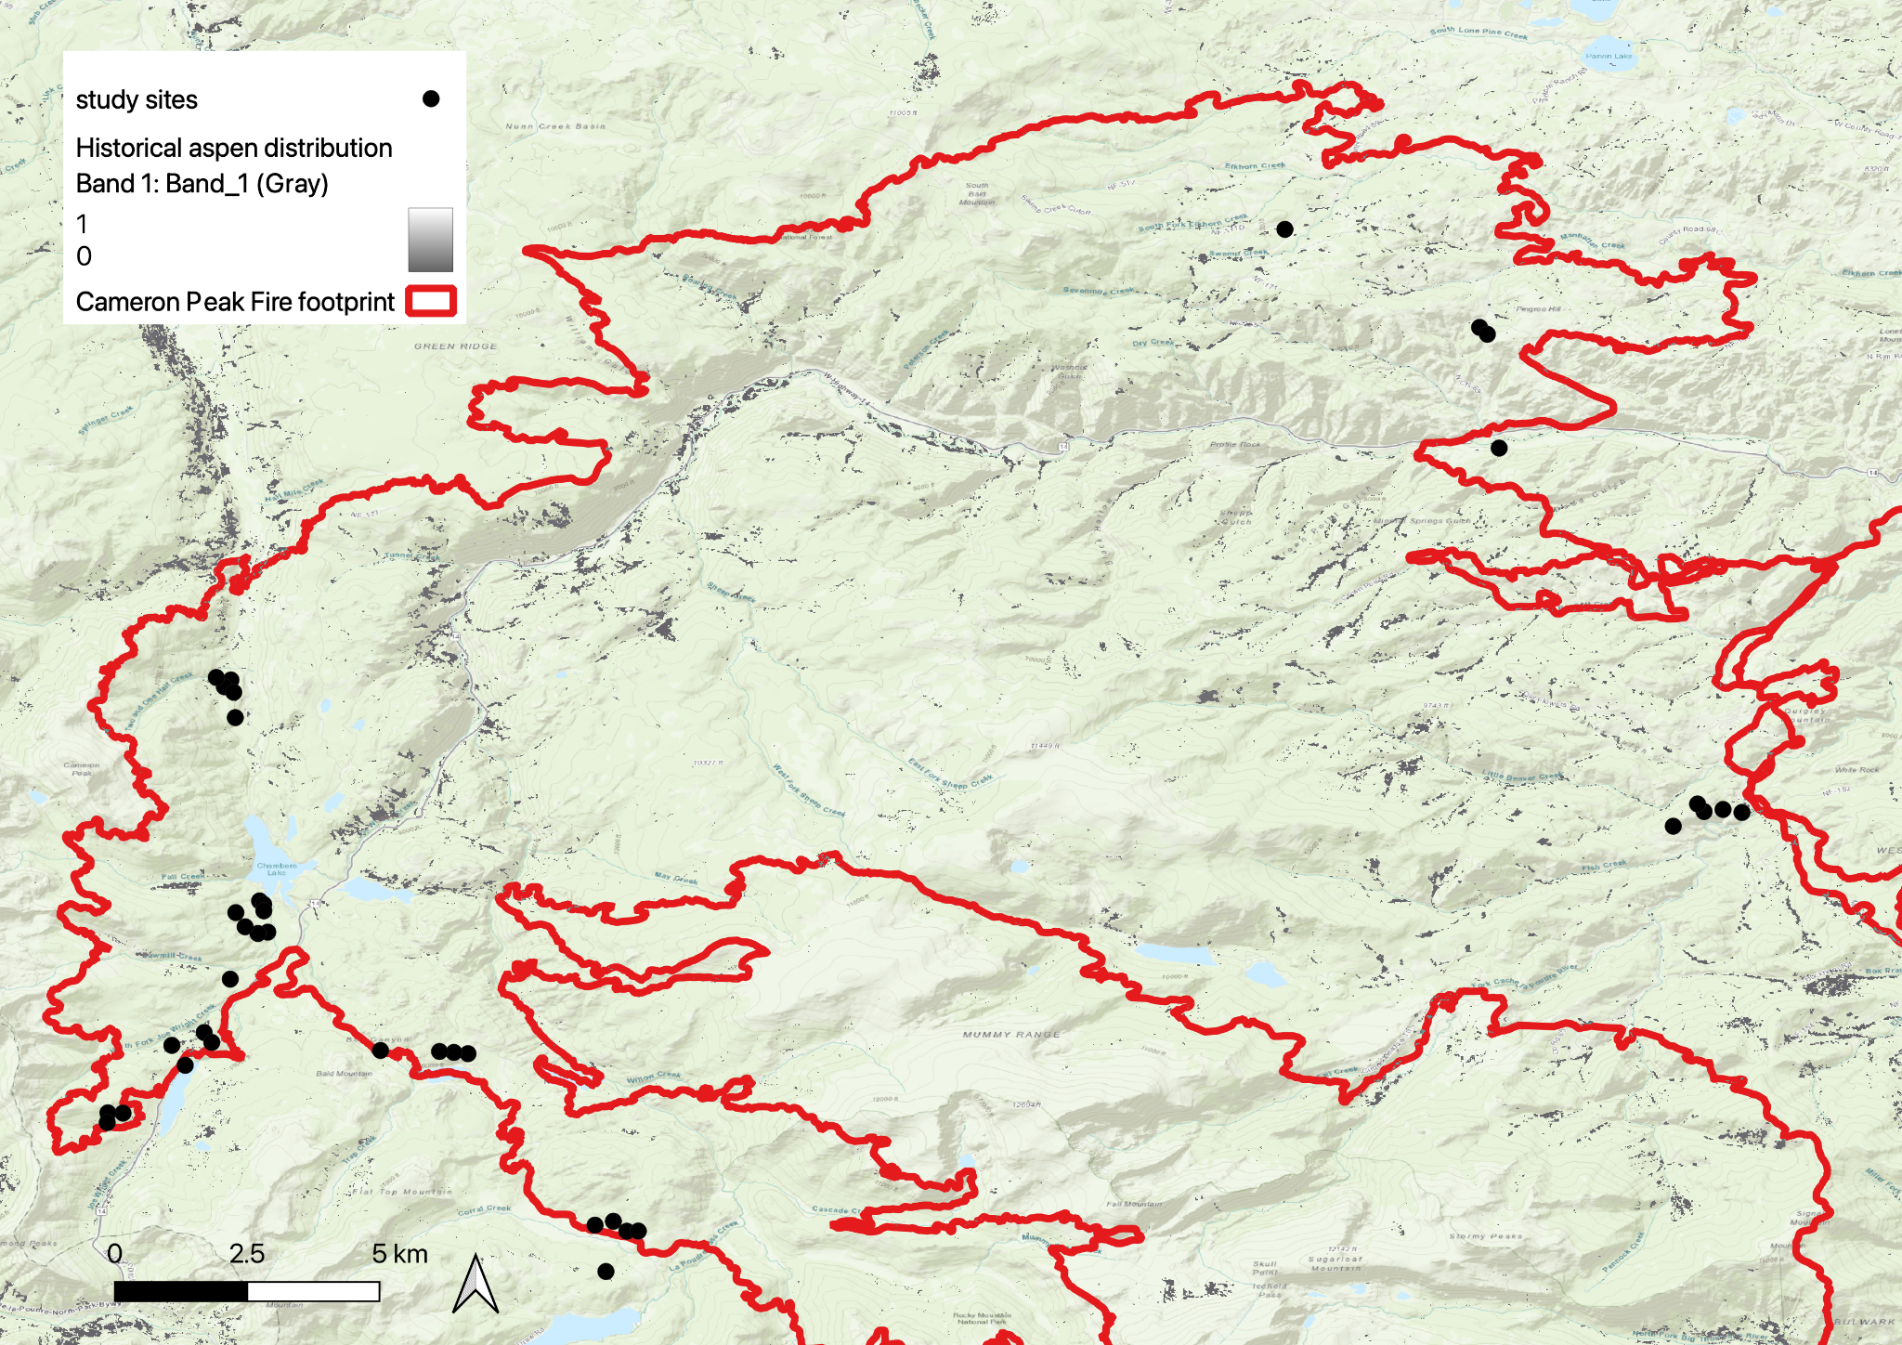

Figure 1. Map of study sites within the extent of the Cameron Peak Fire burn scar (red), overlaid with known historical aspen populations (gray).

## Site selection

We surveyed 38 sites in the summer of 2022. To locate potential sites, we first acquired geospatial data describing the extent of the Cameron Peak fire and patterns of burn severity from the Monitoring Trends in Burn Severity (MTBS) Project. To quantify the proximity of sites to pre-fire aspen cover, we acquired a 10-m resolution map of aspen cover for the Southern Rocky Mountain Ecoregion from Cook et al. (in review). The map represents aspen cover in ca. 2019 and was produced from Sentinel imagery. We combined these data sources to identify areas that: (a) burned at high severity and (b) were located >50 m and <1000 m away from a pre-fire patch of aspen. Sites were further limited to areas of public land that were within 1000 m of a road or 500 m away from a trail and no more than 1 km up the trail. Finally, in order to assume independence, all sites were located >100 m away from a road or trail and >400 meters apart. Despite the extensive area burned, the accessible area was notably restricted by a limited road network and post-fire treatments (e.g. aerial mulching) and damage to infrastructure. As a consequence, sites were geographically clustered in groups of 1-5 sites (Table 1).

Table 1: A summary of site characteristics for the 38 surveyed sites including cluster identity, UTM coordinates for UTM zone 13N, elevation, and pre-fire species composition data measured from the centerpoint of each site.

| Cluster | Site | UTM Northing (m) | UTM Easting (m) | Elevation (m) | Pre-fire species composition |
| --- | --- | --- | --- | --- | --- |
| ELKHORN | 1 | 447029 | 4510687 | 2712 | ponderosa pine, quaking aspen |
| FISH | 2 | 455188 | 4496280 | 2519 | ponderosa pine |
| FISH | 3 | 454831 | 4496229 | 2546 | ponderosa pine |
| LAKE | 4 | 427569 | 4494233 | 2850 | subalpine fir, Engelmann spruce, lodgepole pine |
| LAKE | 5 | 427646 | 4494147 | 2825 | subalpine fir, Engelmann spruce, lodgepole pine |
| LAKE | 6 | 427647 | 4493988 | 2835 | subalpine fir, Engelmann spruce, lodgepole pine |
| RAWAH | 7 | 427082 | 4499706 | 2710 | lodgepole pine, quaking aspen |
| RAWAH | 8 | 426956 | 4499540 | 2724 | lodgepole pine, quaking aspen |
| BLUE | 9 | 427716 | 4493460 | 2865 | subalpine fir, Engelmann spruce, lodgepole pine |
| BLUE | 10 | 427530 | 4493428 | 2898 | subalpine fir, Engelmann spruce, lodgepole pine |
| BLUE | 11 | 427118 | 4493949 | 2901 | subalpine fir, Engelmann spruce, lodgepole pine |
| BLUE | 12 | 427290 | 4493596 | 2926 | subalpine fir, Engelmann spruce, lodgepole pine |
| RES | 13 | 425878 | 4490676 | 3051 | subalpine fir, Engelmann spruce, lodgepole pine |
| RES | 14 | 426126 | 4490180 | 3040 | subalpine fir, Engelmann spruce, lodgepole pine |
| RES | 15 | 426491 | 4490988 | 3025 | subalpine fir, Engelmann spruce, lodgepole pine |
| RES | 16 | 426633 | 4490741 | 3012 | subalpine fir, Engelmann spruce, lodgepole pine |
| RAWAH | 17 | 426806.78 | 4499770.7 | 2715 | lodgepole pine, quaking aspen |
| RAWAH | 18 | 427132.09 | 4499400.49 | 2739 | lodgepole pine, quaking aspen |
| RAWAH | 19 | 427155.54 | 4498773.02 | 2751 | lodgepole pine, quaking aspen |
| SNOW | 20 | 426996.58 | 4492303.55 | 2959 | subalpine fir, Engelmann spruce, lodgepole pine |
| LONG | 21 | 429815.3 | 4490511.37 | 3029 | subalpine fir, Engelmann spruce, lodgepole pine |
| MONTY | 22 | 424940 | 4489009 | 3206 | subalpine fir, Engelmann spruce, lodgepole pine |
| MONTY | 23 | 424655 | 4489019 | 3259 | subalpine fir, Engelmann spruce, lodgepole pine |
| MONTY | 24 | 424640 | 4488778 | 3199 | subalpine fir, Engelmann spruce, lodgepole pine |
| LONG | 25 | 431465 | 4490417 | 3068 | subalpine fir, Engelmann spruce, lodgepole pine |
| LONG | 26 | 431200 | 4490450 | 3099 | subalpine fir, Engelmann spruce, lodgepole pine |
| LONG | 27 | 430929 | 4490476 | 3090 | subalpine fir, Engelmann spruce, lodgepole pine |
| FISH | 28 | 454709 | 4496418 | 2571 | ponderosa pine |
| FISH | 29 | 454247 | 4495871 | 2599 | ponderosa pine |
| FISH | 30 | 455545 | 4496202 | 2462 | ponderosa pine |
| CR69 | 31 | 450677 | 4508236 | 2574 | ponderosa pine, Douglas-fir |
| CR69 | 32 | 450822 | 4508064 | 2611 | ponderosa pine, Douglas-fir |
| CR69 | 33 | 451026 | 4505247 | 2596 | ponderosa pine, Douglas-fir, quaking aspen |
| CAM | 34 | 434425 | 4485996 | 3106 | subalpine fir, Engelmann spruce, lodgepole pine |
| CAM | 35 | 434642 | 4485999 | 3093 | subalpine fir, Engelmann spruce, lodgepole pine |
| CAM | 36 | 434021 | 4485004 | 3020 | subalpine fir, Engelmann spruce, lodgepole pine |
| CAM | 37 | 433826 | 4486153 | 3119 | subalpine fir, Engelmann spruce, lodgepole pine |
| CAM | 38 | 434173 | 4486246 | 3154 | subalpine fir, Engelmann spruce, lodgepole pine |

## Plot design

At each site, we established two perpendicular 2m x 50m transects that intersected at the midpoint (Andrus et al. 2021). The azimuth of the first transect was randomly selected and the second transect was placed perpendicular to the first. At the centerpoint, we recorded plot coordinates, elevation, slope,aspect, and pre-fire tree species composition. We also recorded the distance from the plot center to the nearest pre-fire live mature aspen. If the distance exceeded 50 m, we measured the distance from plot center to nearest prefire live aspen using a 10-m gridded map of the study area produced by Cook et al (in review).

## Field data collection

### Aspen seedling and overall regeneration survey

We tallied the presence of all conifer seedlings, aspen seedlings, and aspen root suckers within the transect and recorded their location along the transect within 2m x 2m subplots. Aspen seedlings were differentiated from root suckers using methods outlined by Kreider et al., (2020), which have been demonstrated to be 96% accurate (Kreider & Yocom, 2021). Prior to implementing these methods, we validated them in the field (see Supplemental Materials). For aspen seedlings and root suckers, we additionally measured height and the presence of browsing damage. For only aspen seedlings, we also recorded information on the microsite conditions including the substrate (Char, Bryophyte, Litter, Mineral soil, Rock, or Wood), microtopographic conditions (Flat, Slope, Concave, or Convex) within 2.5 cm of seedling (hereafter ‘small microtopography’) and within 50 cm of seedling (hereafter ‘large microtopography’), presence or absence of small (diameter = 2.5-10 cm) and large (diameter >10 cm) coarse woody debris (CWD) within 10 cm of seedling, distance to the nearest aspen sucker within 50 m, and presence or absence of canopy cover within 5 m. To understand if seedlings preferentially established in certain microsite conditions, we also collected microsite conditions at 5 meter intervals along each transect.

## Data analysis

### Site-level drivers of seedling occurrence, density, subplot stocking, and height

To understand how site factors (Table 2) influenced aspen seedling occurrence, density, subplot stocking (for instances of >1 seedling per each 2 x 2 m subplot), and height we used a generalized linear mixed effect modeling approach (GLMM). Specifically, we modeled the presence/absence of a seedling within a transect using a GLMM with a binomial-distributed error structure and a logit link. To account for the hierarchical nature of data, we also included a random intercept of site identity nested within cluster identity. Given occurrence at the site scale, we then modeled the number of seedlings present and the count of stocked subplots within a transect using negative-binomial GL MMs, and again included random intercept of site identity nested within cluster identity. Finally, we modeled seedling height using a linear mixed effect (LME) model with a random intercept of site identity nested within cluster identity. To improve model fit, here we used a log transformation on seedling height.

To identify the variables that were most strongly associated with each response variable, we initially built a null model for each response variable that contained only the random effects and no fixed effects. We then added each predictor variable to the null model and then quantified the change in model fit using the AIC statistic. We then built a multivariate model from the subset of predictor variables that were identified as important. For models of aspen occurrence and density, we additionally tested for interactions between distance to the nearest prefire live aspen and all other predictor variables. We had no reason to believe that such interactions would also influence aspen seedling height and so did not test for these effects. Models were fit in R (R Core Team 2024) using the lme4 package (Bates et al. 2015) and residual diagnostic plots were generated using the DHARMa package (Hartig 2022). To visualize the effect of predictor variables on the response, we calculate the estimated marginal mean for the response while accounting for other fixed and random effects using the Effects package (Fox 2003, Fox and Weisberg 2018, 2019).

### Microsite drivers of seedling occurrence

To understand if aspen seedlings preferentially establish in different microsite conditions, we followed the general approach outlined by Kreider and Yocom (2021). Briefly, we first modeled the probability that aspen seedlings occur in each category of the predictor variable using a mixed effect multinomial logistic regression. We then modeled the probability that systematically surveyed points occurred in each category of the variable. We used these two models to quantify microsite preference following methods outlined by Krieder and Yocom (2021) .

$preference = \frac{prob. of seedling occur in the microsite category - prob. of microsite category avail.}{prob of microsite category avail.}*100$

Here, preference values greater than zero indicate seedlings established in that microsite condition more often than expected. Multinomial regression was performed in R (R Core Team 2024) using the mclogit package (Elff 2022). Preliminary analyses that included a random intercept term of site identity nested within clusters decreased modeled fit, and so final models only included site identity as a random effect.

Table 2: Summary potential predictor variables for the occurrence, density, and height of aspen seedlings and their respective parameters within the context of our study sites.

| Predictor | Scale | Description | Values |
| --- | --- | --- | --- |
| Elevation | Site | Height above sea level in meters | 2462 m - 3259 m |
| Slope | Site | Slope in degrees | 0 - 48 |
| Aspect | Site | Sine-transformed folded aspect | 12 - 342 |
| Seed source distance | Site | Distance from plot center to nearest historical aspen colony, alive or dead | 0 - 1000 m |
| Understory vegetation | Subplot | Average % vegetative cover categorized by forb, graminoid, and shrub classes | 0 - 92% |
| Seedling Density | Subplot | Density of seedlings within a subplot | 0 - 9.5 seedlings/m^2 |
| Small Microtopography | Seedling | Microtopography within 10 cm surrounding a seedling | Flat (F), Slope (S), Concave (CC), Convex (CV) |
| Large Microtopography | Seedling | Microtopography within 25 cm surrounding a seedling | Flat (F), Slope (S), Concave (CC), Convex (CV) |
| Substrate | Seedling | Surface material seedling is growing from | Mineral soil (M), Char (C), Bryophyte (B), Litter (L), Wood (W), Rock (R) |
| Large CWD | Seedling | Presence of CWD > 10 cm in diameter within 25 cm | Presence or absence |
| Small CWD | Seedling | Presence of CWD with diameter between 2.5 - 10 cm within 25 cm | Presence or absence |
| Sucker Distance | Seedling | Distance in meters to the nearest aspen sucker (up to 50 m) | 0.9 - not observable |
| Browse | Seedling | Presence of browse on a seedling | Presence or absence |
| Canopy cover | Seedling | Presence of live canopy cover within 5 m | Presence or absence |

# Results

Across the 38 sites sampled, we identified 561 total aspen seedlings, which were present at 66% of sites (25/38) and 100% of clusters (11/11). Seedling density was highly variable, and ranged between zero and 8,500 per hectare.. Of the surveyed seedlings, 16.6% (93) experienced browse across 18 of the 38 sites, despite signs of ungulate activity, including hoof print depressions and excrement, occurring more commonly. Conifer regeneration was much more limited, despite most plots being located in stands that were dominated by conifers prior to fire (Table S1). Spruce and fir regeneration was especially low and averaged just over six seedlings per hectare for subalpine fir and approximately 65 seedlings per hectare for Engelmann spruce across all transects that contained these species pre-fire. We observed subalpine fir seedlings at just one site, despite the presence of pre-fire fir at 24 sites. Lodgepole regeneration was relatively higher, at approximately 160 seedlings per hectare. Across the nine sites that contained pre-fire ponderosa pine, we calculated mean regeneration to be approximately 83 seedlings per hectare. Only three sites contained pre-fire Douglas-fir, with a mean regeneration of 50 seedlings per hectare.

*Patterns of aspen seedling occurrence*

Our best fitting model of seedling occurrence showed a relationship with elevation. This model explained roughly 64% of the variation in seedling occurrence patterns (conditional r2 = 0.638), however much observed variation was attributed to the random effects (marginal r2 = 0.091, Table S2). We observed a weakly positive relationship between increasing elevation and aspen seedling presence, however this effect was not significant (p = 0.126). 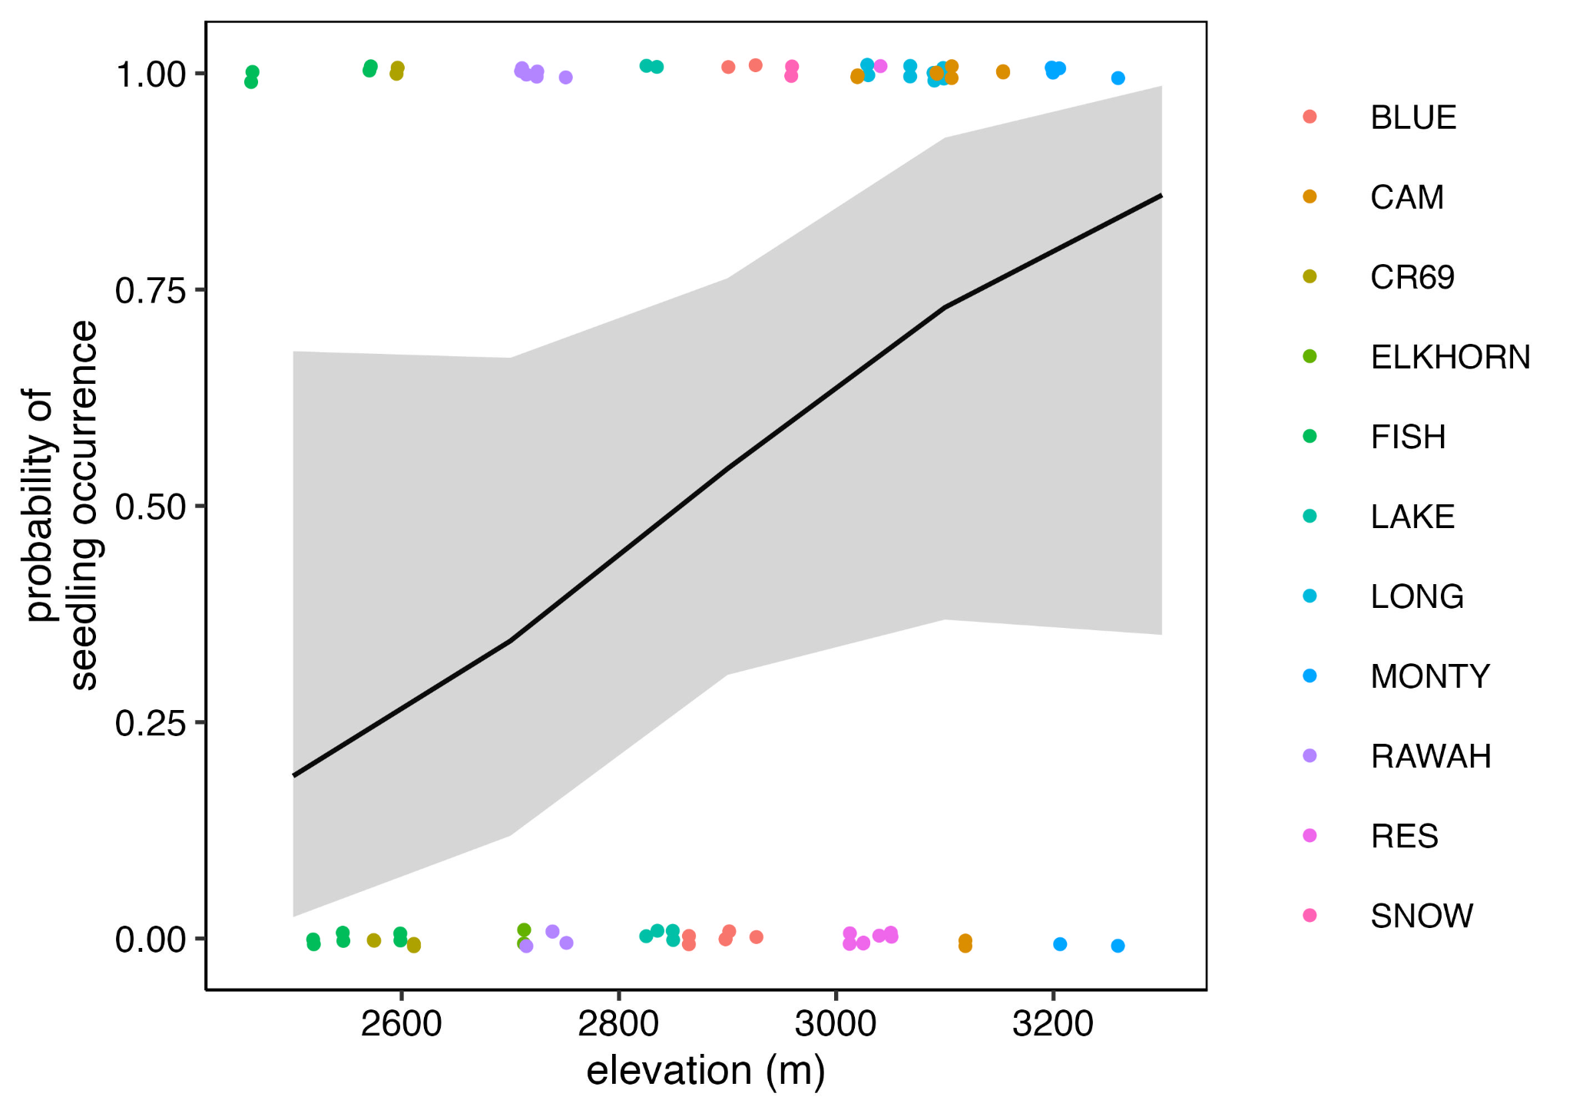Figure 2. The estimated marginal mean probability of seedling occurrence within a transect by elevation. Sampling clusters are differentiated by point color. Shaded areas show the 95% confidence interval.

*Patterns of seedling density*

Given the occurrence of a minimum of one seedling within a transect, our GLMM indicated a significant relationship between density and elevation (p = 0.017). The best fitting model accounted for 76% of variation in seedling density at occupied sites (conditional r2 = 0.757), but again random effects were the driving factor behind the majority of variation (marginal r2 = 0.218; Table S3). 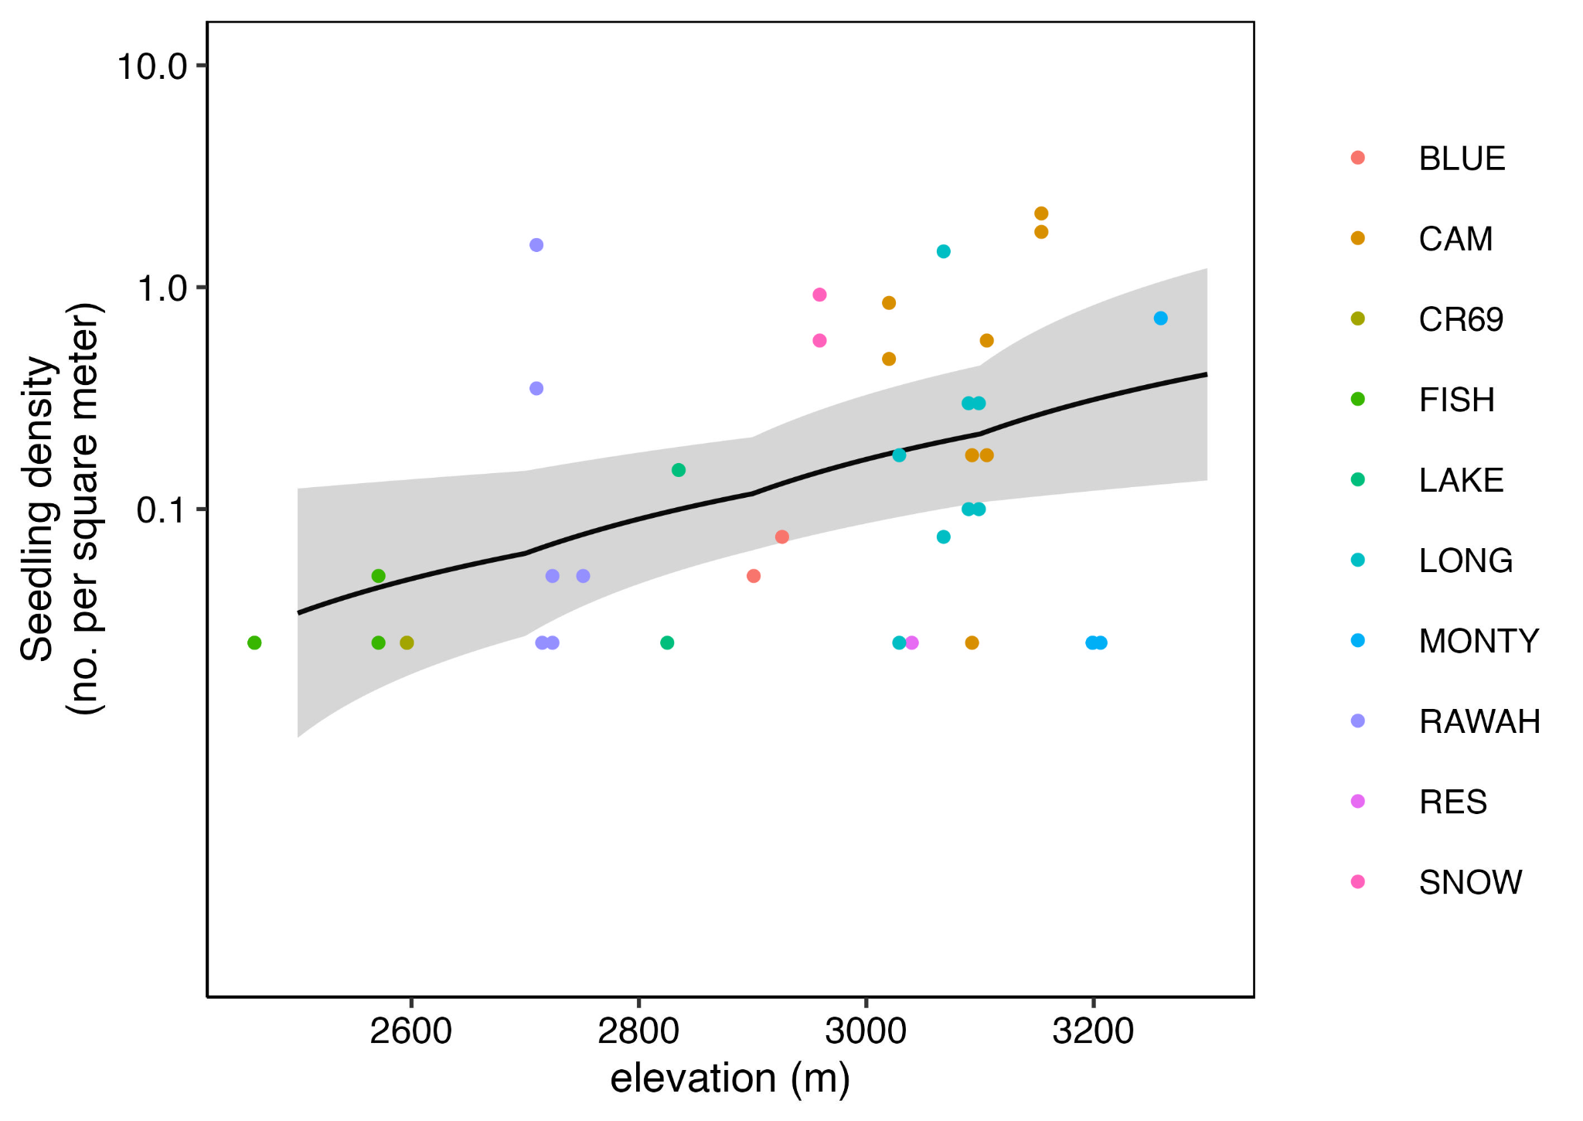

Figure 3. The estimated marginal mean seedling count within a transect in relation to elevation given seedling occurrence.. Sampling clusters are differentiated by point color. Shaded area represents the 95% confidence interval.

## Patterns of subplot stocking

Our GLMMs indicated elevation (p < 0.001) was the only significant variable influencing seedling stocking (Fig. 4). The majority of variation explained by random effects (Marginal r2 = 0.468) as compared to fixed effects (conditional r2 = 0.192) (Table S4).

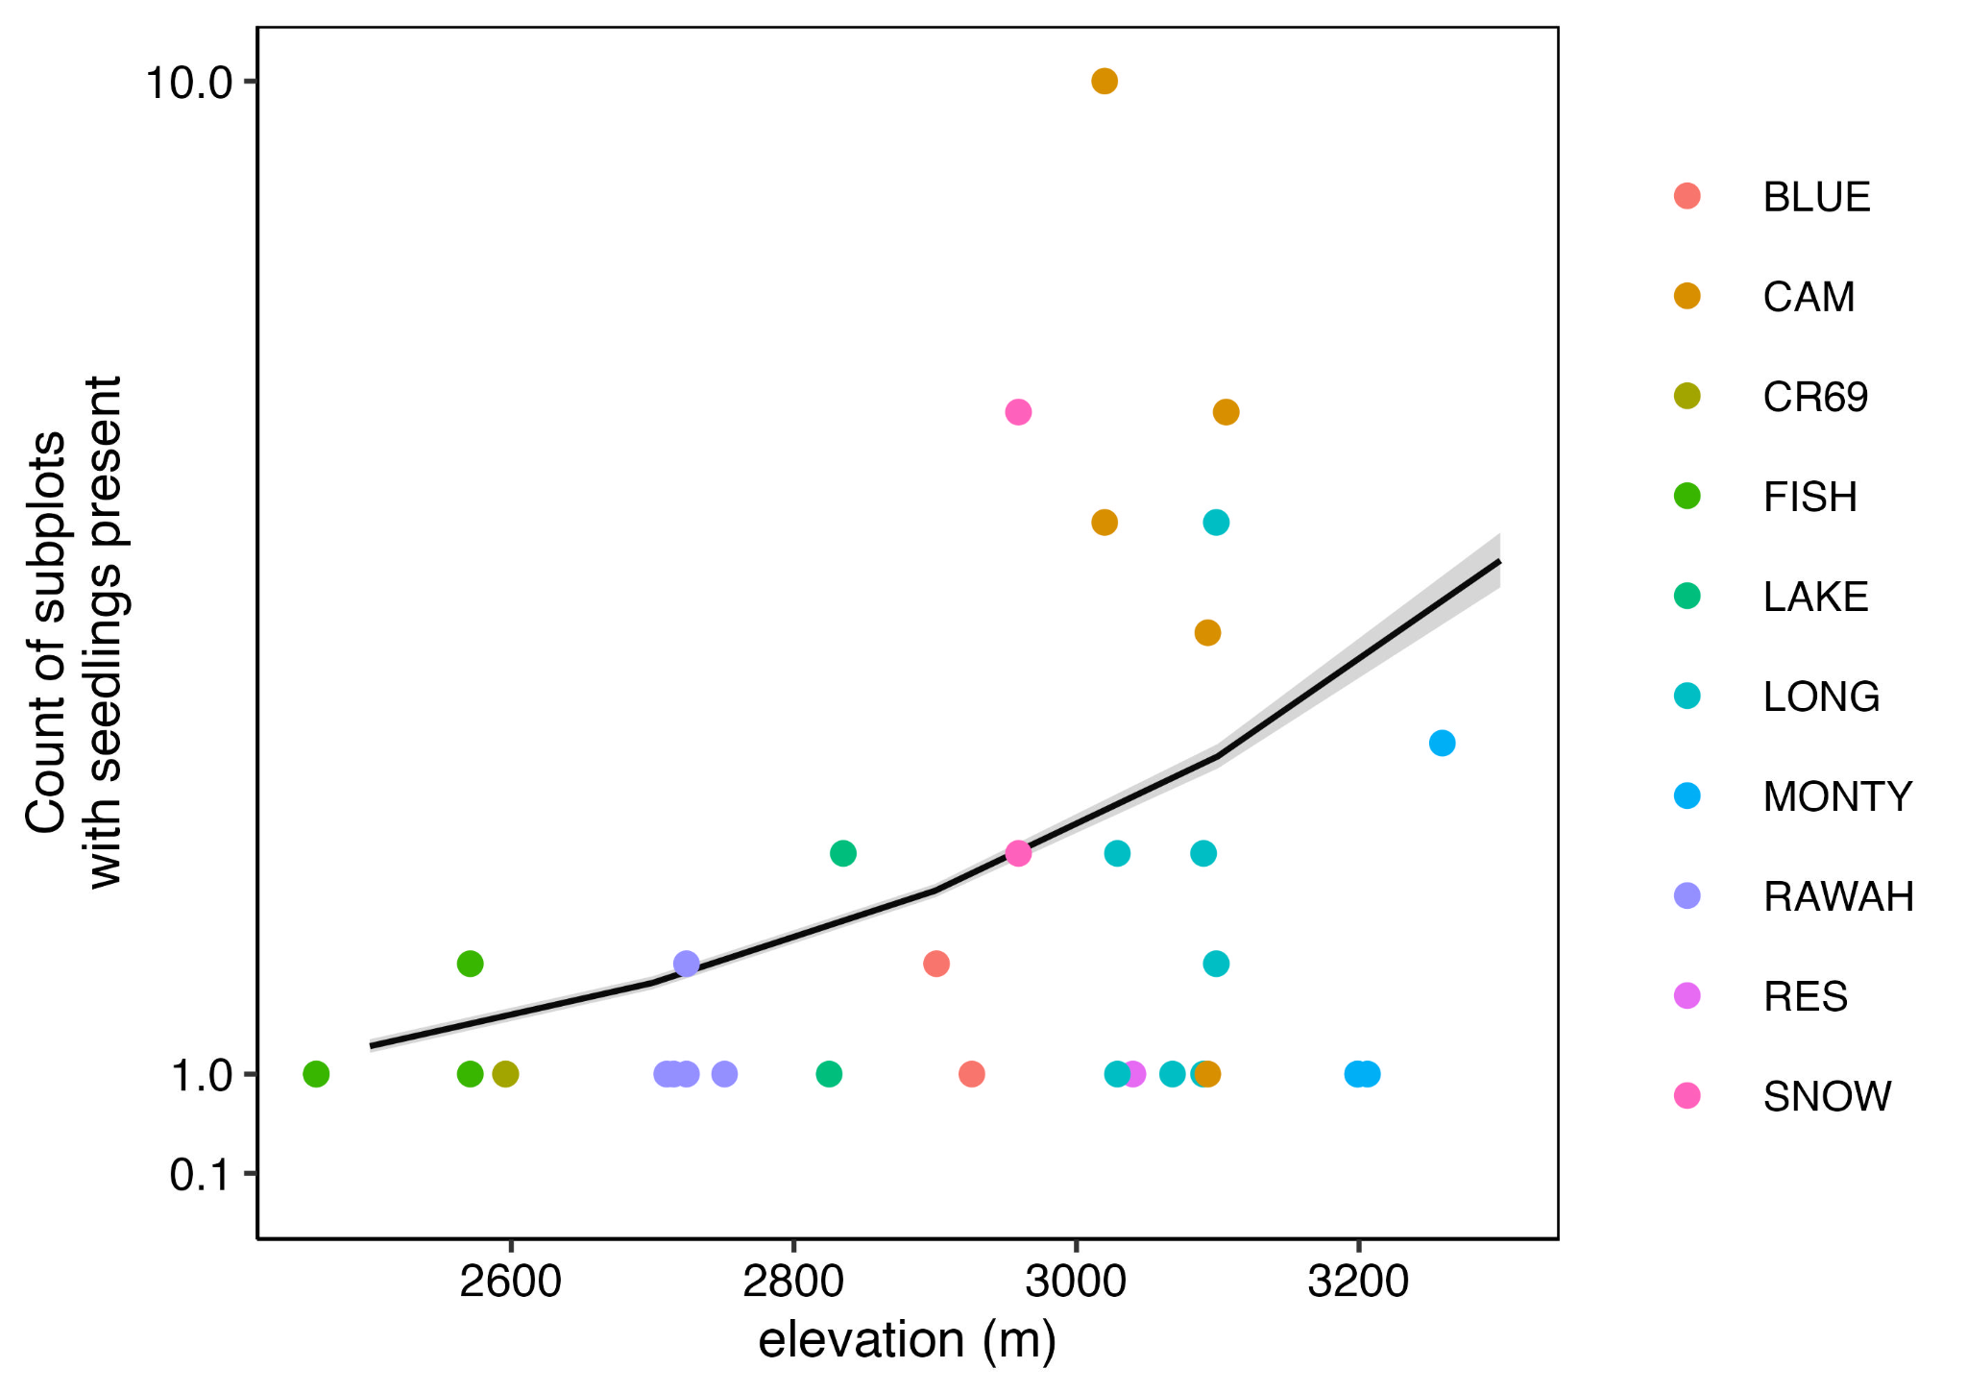

Figure 4. The estimated marginal mean of the count of stocked subplots (>= 1 seedling) in a transect, given occurrence, in relation to elevation. Sampling clusters are differentiated by point color. Shaded area represents the 95% confidence interval.

*Patterns of seedling height*

Seedling height was negatively associated with elevation (p ≤ 0.001). Our GLMM indicated that the vast majority of variation in height was driven by random effects, though model explanatory power was low overall both low marginal and conditional r2 values. (marginal r2 = 0.164, conditional r2 = 0.273) (Table S5).

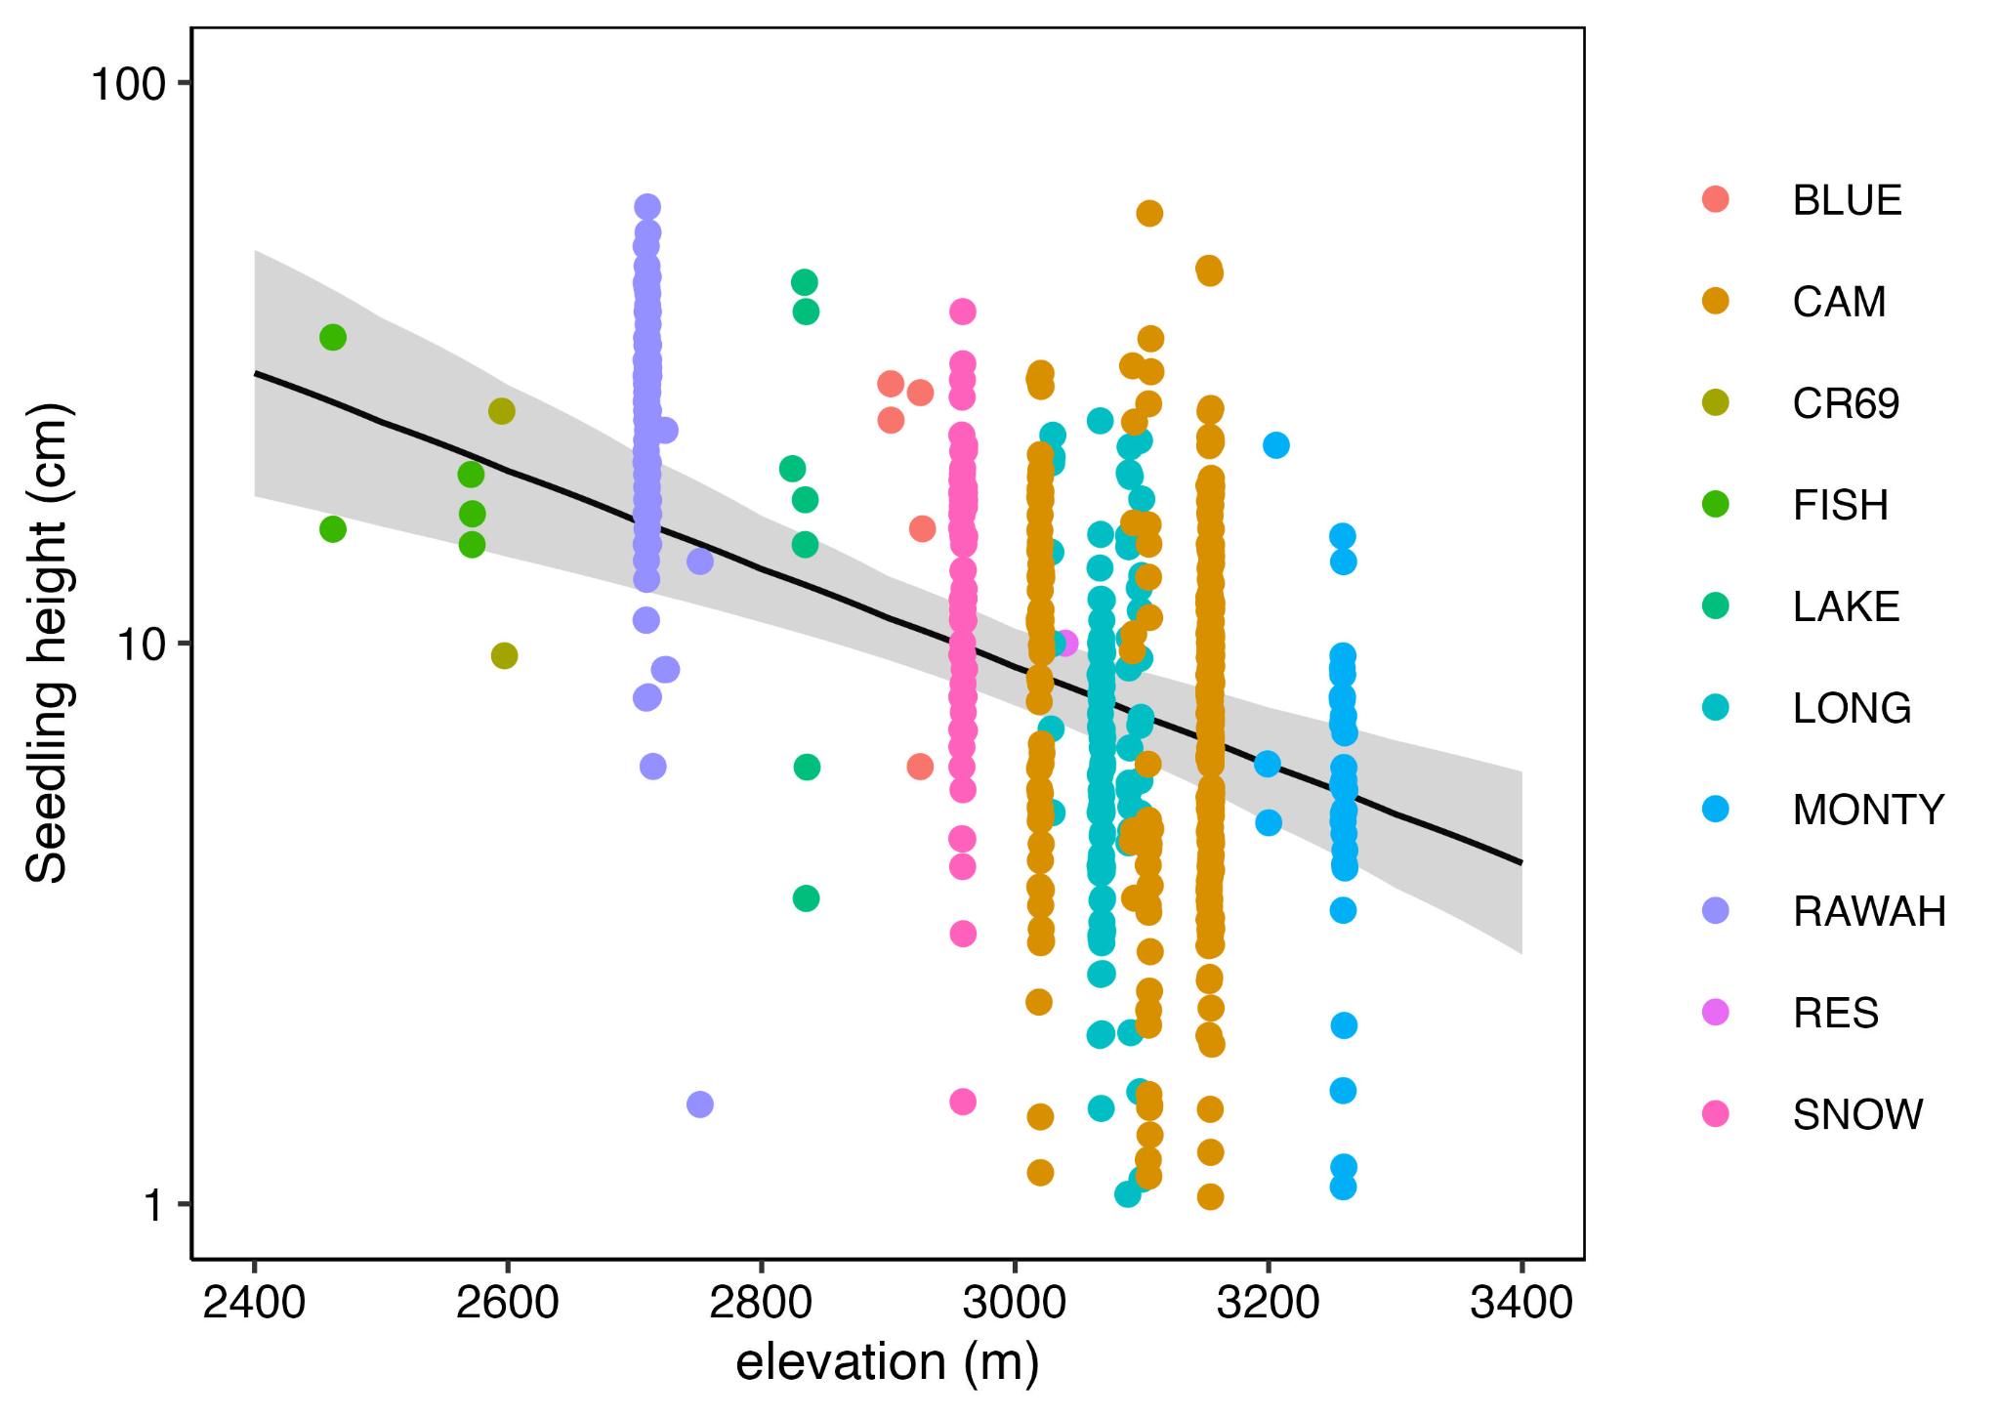

Figure 5. Estimated marginal mean of seedling height by elevation. Sampling clusters are differentiated by point color. Shaded area shows a 95% confidence interval.

*Microsite preference*

Qualitatively, we observed seedlings were more likely to occur within localized riparian patches, where bryophytes were the dominant substrate (Fig. S6). Relative to overall prevalence on the landscape, our statistical model showed that seedlings preferentially established on char and bryophyte substrates where small CWD was absent, but large CWD was present, and in concavities at both small and large scales (Fig. 7). Establishment on bryophytes was most prevalent, with 45.6% (256/561) of total seedlings. Similarly, establishment in char was high, with 39.9% (224) of seedlings. Despite being the most abundant substrate type across the landscape as a whole, establishment was relatively low in bare mineral soil, with only 9.8% (55) of seedlings. Additional less abundant substrate types included litter (4.8% of seedlings), wood (0.7% of seedlings), and rock (0% of seedlings).

Measurements of both large (10 cm surrounding seedling) and small (2.5 cm surrounding seedling) microtopography indicated a seedling preference for concave surfaces, with 41.9% (235/561) of seedlings and 34.2% (192) of seedlings respectively establishing in concavities at the large and small scales. This was supported by our model, which showed a greater seedling occurrence at concave microsites compared to their relative abundance on the landscape as a whole. ConcordantlyHowever, seedlings were less likely to populate flat and sloped microtopographies relative to their prevalence on both the small and large scale (Fig. 7). Cavities and micro-depressions existed across the landscape at all site types, and in some cases indicated pockets of above average moisture as indicated by the presence of bryophytes. Further, we observed that seedlings in small groups of 2 - 6 seedlings per microtopographic depression. Furthermore, we observed clustering behaviors on a larger scale in cavities created by fallen snags, both in and outside of areas with high resource abundance, indicating that topography on a scale 0.5-1.5 m may also influence establishment trends (Fig. S7). Of the seedlings surveyed, 43.1% (242/561) were located within 25 cm of large CWD . Modeling confirmed a significant seedling preference for large CWD compared to its overall availability (Fig 7).

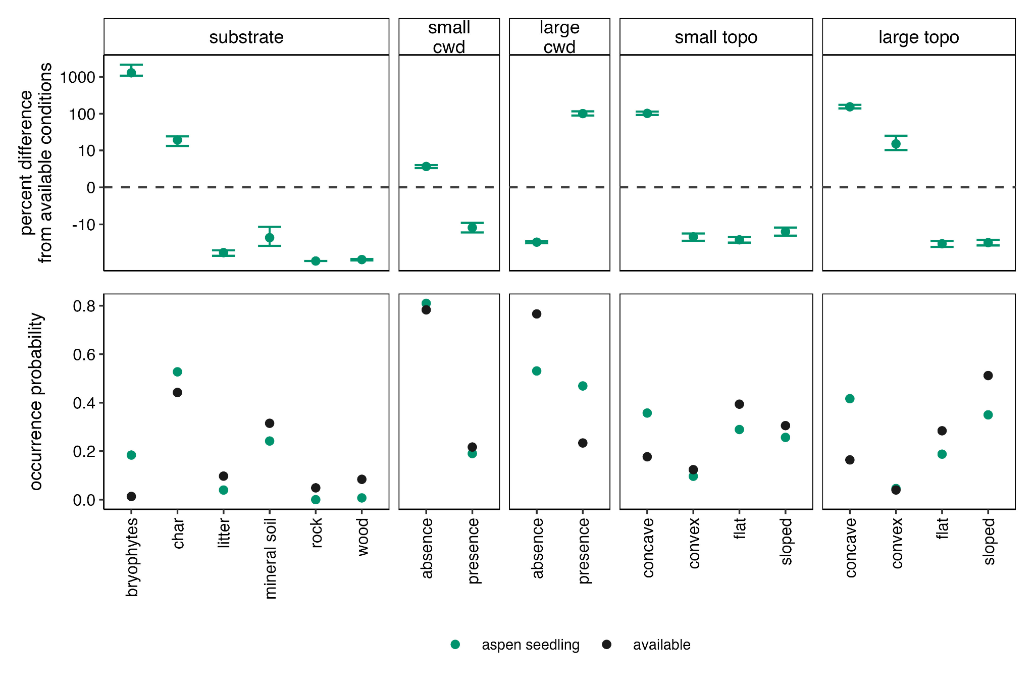Figure 7. Comparison of seedling microsite preference (top) relative to predicted probability of occurrence (bottom) based on overall prevalence of a condition or resource on the landscape.

*Root suckers*

Root suckers were present within 50m of site center at 15.8% of sites (6/38), and of that 10.5% of sites contained root suckers (4/38) within the bounds of at least one subplot.

# Discussion

Here we found abundant establishment of quaking aspen seedlings across high severity burn zones within the bounds of the Cameron Peak Fire, the majority of which did not contain pre-fire aspen. Seedling occurrence, stocking, and density were all significantly related to elevation, with positive associations at higher elevations up to 3200 m. We observed 83.6% of aspen seedlings occurring above 2713 m, and of that, 57.4% occurring above 3064 m. Furthermore, aspen seedlings greatly outnumbered observed regeneration of the pre-fire dominant conifer species, including Engelmann spruce, subalpine fir, and lodgepole pine. While at the transect scale aspen seedling occurrence was widespread, densities of aspen seedlings were highly variable. Collectively, our work adds to the growing body of research that shows post-fire seedling establishment is an important process shaping the ecology of burned ecosystems, at least in the near-term (Kreider & Yocom, 2021; Nigro et al. 2023).

We conducted our survey exclusively in high severity burn zones characterized by 100% stand mortality of the pre-fire stand, which may create conditions conducive for seedling establishment. First, a lack of canopy, combined with little to no understory vegetation may have reduced blockages or “traps” that would ordinarily stop the movement of windborne seeds and therefore allow for long distance dispersal (Reitschmiedov´a et al., 2022). Furthermore, high percentages of bare substrate and increased instances of runoff and erosion on post-burn landscapes could further serve to distribute seeds across the landscape. This would allow greater potential for long distance dispersal compared to unburned forest conditions.

The positive relationship between elevation and seedling occurrence we observed here may be explained by greater climatic suitability at higher elevations (Quinn & Wu, 2001). Notably, higher elevations are characterized by cooler summers and greater winter snowpack accumulation and retention, which lead to lower moisture stress for plants. Low elevation sites, in addition to already being at the lower bounds of aspen habitat suitability (Rehfeldt et al. 2009), were also characterized by greater understory cover and higher root sucker densities, which may both outcompete aspen seedlings and occupy the substrate preferred by seedlings (Kreider & Yocom, 2021).

The positive relationship between seedling occurrence, density, and elevation may also be indicative of climate-catalyzed range shifts (Nigro et al., 2022, Kreider & Yocom, 2021). High severity fire can serve as a catalyst for range shift, removing competitive barriers to species movement and exacerbating driving climatic pressures (Nigro et al., 2022). A lack of seeds or suitable microsite conditions may limit regeneration of the pre-fire dominant tree species, while leaving a competitive niche open for other species, in some cases facilitating post-fire state shifts from forest to grassland (Nigro et al., 2022, Stevens-Rumann et al., 2018). However, the ability for aspen seedlings to establish in novel, high elevation zones following fire may serve as an important foundation for both range expansion. Range shifts towards higher elevations initiated by aspen seed dispersal may also be the most effective means of mitigating predicted aspen and overall forest cover loss due to climate pressures (Kreider & Yocom, 2021).

The majority of the landscape was characterized by scattered low-density aspen seedling distribution on bryophyte and bare, exposed char substrate. Higher densities of seedling establishment were observed in riparian patches and micro-depressions in the landscape, often created by fallen snags. Riparian patches, which were primarily evident at high elevation sites, contained adequate moisture, seed retention, and cover material to host high densities of seedlings. These patches indicated an accumulation of moisture, either in the form of standing or flowing surface water or increased subsurface soil moisture. We observed that presence or absence of standing or flowing water did not appear to impact the prevalence of seedling occurrence. However, high percentages of riparian graminoid cover reduced the amount of exposed ground available for seedling establishment. Live vegetative cover was relatively high, as was presence of bryophyte substrate, which existed almost exclusively in these patches (Fig. S6). However, bryophyte cover was low enough in height to not pose a competitive threat to aspen seedling establishment.

Riparian zones represented pockets of high moisture accumulation on an otherwise dry and barren landscape, usually located in shallow depressions or drainages. Riparian pockets were a reliable indicator of seedling clustering, as well as presence of the majority of bryophyte-dominant substrate most preferred by seedlings. Ample moisture availability reduced competitive limitations, allowing for the high density clustering behavior observed by other studies (Kreider & Yocom, 2021, Turner et al., 2003). Our maximum density of 8,500 seedlings per hectare was much lower than that of both Turner et al., who observed a maximum density of 46,000 seedlings/ha (Turner et al., 2003), and Kreider and Yocom (2021) whose maximum recorded density was 318,000 seedlings/ha, but higher than that of Quinn and Wu (2001) who reported a maximum density of 2,700 seedlings/ha. Like our study, seedling density was highly varied, with reported median densities of 1,100 seedlings/ha and 2,000 seedlings/ha respectively (Kreider & Yocom, 2021 a, Turner et al., 2003). These disparities may be influenced by factors including geographical location, forest type, time since burn, mean annual precipitation in years preceding each study, and characteristics of each fire. Work conducted by Kreider and Yocom (2021) focused on fires throughout the Western United States occurring within a comparable time period, however most were much smaller burn footprints than that of Cameron Peak. Quinn and Wu (2001) and Turner et al. (2003) conducted research on larger singular fire footprints approximately two decades before the work of our study, leaving potential for differing patterns of temperature, precipitation, and pre-fire conditions that impacted study results.

Scattered micro-depressions on the landscape likely served as accumulation points for moisture, nutrients from runoff, and aspen seeds, as well as a source of protection on an otherwise exposed landscape (Kreider & Yocom, 2021). This most commonly occurred in the form of small cavities created by the uprooting of fallen snags (Fig. S7). Independently of riparian pockets, these cavities were a reliable indicator of seedling occurrence, regardless of the conditions of the surrounding landscape. This is likely due to a combination of localized resource availability and microtopography conducive to seed retention. In addition to housing moisture necessary for seedling survival relative to the surrounding exposed landscape, these cavities may have served to trap and shelter wind-dispersed seeds.

At a microsite scale, seedling occurrence was related to the presence of coarse woody debris and concave microtopography, both of which may have connections to seed retention and moisture availability (Kreider & Yocom, 2021, Fairweather et al., 2014). The presence of large coarse woody debris (diameter > 10 cm) had a positive relationship with seedling occurrence. Fallen logs or other large debris may both shelter and trap wind-dispersed seeds, thus increasing the close proximity of establishment we observed (Kreider & Yocom, 2021). Similarly, concave microtopography and areas sheltered by large CWD may serve to collect both seeds and moisture necessary for successful establishment and survival in the first 1-3 growing seasons (Fairweather et al., 2014).

While seedling height had a mildly negative relationship with elevation, our modeling indicated a high degree of unaccounted variables or random factors. Notably in our modeling we did not include the potential effects of seedling densities, which were positively associated with elevation. The limited explanatory fit of our model suggests that one or more relevant variables to seedling height were not considered, such as herbivory. However, the mean height of seedlings that experienced browse were actually higher than that of the mean height of all seedlings, browsed and unbrowsed. This suggests that seedlings selected for herbivory were taller and more developed than the average aspen seedling in its first or second year of growth. Sites with the highest seedling counts tended to have a lower mean seedling height (Figure S2, Figure S3). However, these sites also contained outlier individuals that were taller than average. (Figure S3). Stocked sites containing riparian pockets of high seedling density also possessed greater moisture availability; it is unlikely that competition between seedlings for resources was a driving factor behind shorter seedling heights. Rather, more and smaller seedlings in an area of high density may be indicative of greater seed retention and first season growth.

It is unclear how these relationships extend beyond this study’s limitation to a relatively small number of sites within a single geographical area and burn scar. Findings of this study may not be representative of aspen seed establishment trends across the entire burn scar of this fire or patterns observable for other fires. Further exploration could be expanded to examine a greater number of sites at the higher elevational boundaries of aspen establishment, as we surveyed few sites above 3200 m. Similarly, we did not explore the upper limit of seed dispersal, or distance from potential parent tree; our findings indicated an increase in seedling density with greater distance from parent tree up to 1000 m, however our data does not account for distances beyond this nor is there any way to identify specific parent trees. Previous studies indicated a negative association between seed source distance and seedling occurrence, which suggests that increasing potential dispersal ranges may yield differing results (Kreider & Yocom, 2021). In addition, only high severity zones were surveyed, leaving trends of aspen seedling recruitment in low-moderately burned sites unexplored. However, this may not be consequential, as Kreider and Yocom observed no relationship between burn severity and seedling occurrence in the Brian Head fire footprint when surveying high and moderate severity sites (Kreider & Yocom, 2021a). While there was no significant difference between burn severities, the difference between burned and unburned sites was tangible (Kreider & Yocom, 2021a, Turner et al., 2003).

*Conclusion and implications*

Impacts of climate change on forests in western North America are intensifying, leading to increased fire frequency, severity, and extent, some of which may go beyond dominant species’ capacity to recover or even maintain historical distributions (Carlson et al., 2020, Hessburg et al., 2021). As a result of increased wildfire severity and frequency, there has been a marked decrease in resilience of conifer forests, primarily due to increased beetle activity, seed bank destruction, and climatic conditions not conducive to regeneration (Kreider & Yocom, 2021). Higher temperatures and intensified drought conditions may reduce or prevent the regeneration of formerly dominant tree species that established under cooler and wetter conditions (Carlson et al., 2020, Stevens-Rumann et al., 2018). This has led to changes in species dominance, forest composition, and trajectories of ecosystem recovery (Andrus et al., 2021). We observed this phenomenon in high severity zones of the Cameron Peak Fire, where we found low overall regeneration of conifer species after two growing seasons, especially at higher elevation sites, where spruce and fir species were dominant pre-fire.

Changing environmental and climatic conditions may necessitate more dependence on aspen regeneration by seed, especially following high severity fire. The interior of larger burn scars isolated from unburned trees may face difficulties in seed dispersal and seed bank replenishment, especially from non-serotinous, non-pioneer species (Carlson et al., 2020). Long term loss of conifer forest may occur in areas where distance to a viable seed source is as low as 100 m. (Carlson et al., 2020). Post-burn conditions may also lend themselves well to wind dispersed seed, as long distance spread is heavily impacted by canopy density, tree height, and branch elasticity (Reitschmiedov´a et al., 2022). High severity fires that culminate in total canopy loss may reduce obstructions and increase the successful spread of aspen seeds via wind. All these factors combine to indicate an increased reliance on aspen seedlings for the continuation of forest cover in any form.

Further implications of this process include the shift of historically conifer dominant stands to aspen, as aspen seedlings have been shown to be present in recent years following fire in more burn scars than any singular conifer species (Kreider & Yocom, 2021). However, in the long term, there is potential for the eventual shift back to conifer dominance or mixed aspen-conifer forest through facilitation processes (St. Clair et al., 2013, Bartos, 2001). The canopy cover and higher soil moisture retention by an established aspen colony foster more suitable conditions for the survival and establishment of spruce and fir seedlings (St. Clair et al., 2013). However, this process, if it occurs, will only be evident across a multidecadal scale and cannot be depended on for short-term forest management. The success of aspen seedlings at colonizing post-burn landscapes may have other important implications for forest management.

Outside of natural regenerative processes, aspen seedlings have the potential to serve an integral role in reforestation operations. Because of the ability of aspen seedlings to establish in the harshest high severity burned patches, aspen seeds are a strong candidate for distribution into recent fire scars. For example, the release of seeds via helicopter mulching, a process already occurring within our study area, could serve as an efficient means of facilitating reforestation across large swaths of burned land. Distribution and establishment patterns of aspen seedlings may also serve as a useful species to examine patterns of climate and disturbance-driven range shift.

Establishment of aspen by seed following wildfire is not limited to a single burn scar or geographical area and may be highly topographically complex, ranging from small patches to large stands (Howe et al., 2020, Kreider & Yocom, 2021). The occurrence and frequency of aspen seedling establishment within the initial years following the Cameron Peak Fire indicates their importance in populating severely burned landscapes. As the greater impacts of climate change intensify, the establishment of aspen seedlings may play a larger role than ever before in post-disturbance successional processes, with aspen serving as an integral pathway in forest regeneration and persistence (Crouch et al., 2023).

# 

# 

# 

# 

# 

# 

# 

# 

# 

# 

# 

# 

# 

# 

# References

Andrus, R. A., S. J. Hart, N. Tutland, and T. T. Veblen. (2021). Future dominance by quaking aspen expected following short-interval, compounded disturbance interaction. Ecosphere 12:e03345.

Bartos, DL. Landscape dynamics of aspen and conifer forests. (2001). WD Shepperd et al (compilers). Sustaining Aspen in Western Landscapes: Symposium Proceedings. Proceedings RMRS-P-18. U.S. Department of Agriculture, Forest Service, Rocky Mountain Research Station. Fort Collins, CO.

Bates, D., M. Mächler, B. Bolker, and S. Walker. (2015). Fitting linear mixed-effects models using lme4. Journal of Statistical Software 67.

Carlson, A. R., Sibold, J. S., & Negrón, J. F. (2020). Canopy structure and below-canopy temperatures interact to shape seedling response to disturbance in a Rocky Mountain subalpine forest. *Forest Ecology and Management*, *472*, 118234. https://doi.org/10.1016/j.foreco.2020.118234

Crouch, C. D., Rogers, P. C., Moore, M. M., & Waring, K. M. (2023). Building ecosystem resilience and adaptive capacity: A systematic review of aspen ecology and management in the southwest. *Forest Science*, *69*(3), 334–354. <https://doi.org/10.1093/forsci/fxad004>

Cook, M., S. J. Hart, A. Paudel, and J. Balch. In review. Mapping quaking aspen (*Populus tremuloides* Michx) across the Southern Rockies with multi-temporal Sentinel-1 and Sentinel-2 composite imagery in Google Earth Engine.

Davis, K. T., Dobrowski, S. Z., Higuera, P. E., Holden, Z. A., Veblen, T. T., Rother, M. T., Parks, S. A., Sala, A., & Maneta, M. P. (2019). *Wildfires and climate change push low-elevation forests across a critical climate threshold for tree regeneration*. https://doi.org/10.5061/DRYAD.PC3F9D8

Elff M. 2022. mclogit: Multinomial Logit Models, with or without Random Effects or Overdispersion. R package version 0.9.6. Available online: [https://CRAN.R-project.org/package=mclogit](https://cran.r-project.org/package=mclogit).

Fairweather, M. L., Rokala, E. A., & Mock, K. E. (2014). Aspen seedling establishment and growth after wildfire in central arizona: An instructive case history. *Forest Science*, *60*(4), 703–712. https://doi.org/10.5849/forsci.13-048

Fox, J. 2003. Effect Displays in R for Generalised Linear Models. Journal of Statistical Software, 8(15), 1-27. doi 10.18637/jss.v008.i15

Fox, J. and S. Weisberg. (2018). Visualizing Fit and Lack of Fit in Complex Regression Models with Predictor Effect Plots and Partial Residuals. Journal of Statistical Software, 87(9), 1-27. doi: 10.18637/jss.v087.i09

Fox, J. and S. Weisberg. 2019. An R Companion to Applied Regression, 3rd Edition. Thousand Oaks, CA. Available online: <https://socialsciences.mcmaster.ca/jfox/Books/Companion/index.html>

Hartig F. 2022. DHARMa: Residual Diagnostics for Hierarchical (Multi-Level / Mixed) Regression Models. R package version 0.4.6. Available online: [https://CRAN.R-project.org/package=DHARMa](https://cran.r-project.org/package=DHARMa).

Hessburg, P. F., Prichard, S. J., Hagmann, R. K., Povak, N. A., & Lake, F. K. (2021). Wildfire and climate change adaptation of western North American forests: A case for intentional management. *Ecological Applications*, *31*(8), e02432. <https://doi.org/10.1002/eap.2432>

Hill, A. P., & Field, C. B. (2021). Forest fires and climate-induced tree range shifts in the western US. *Nature Communications*, *12*(1), 6583. https://doi.org/10.1038/s41467-021-26838-z

Howe, A. A., Landhäusser, S. M., Burney, O. T., Long, J. N., Violett, R. D., & Mock, K. E. (2020). Exploring seedling-based aspen (*Populus tremuloides*) restoration near range limits in the Intermountain West, USA. *Forest Ecology and Management*, *476*, 118470. <https://doi.org/10.1016/j.foreco.2020.118470>

Hurteau, M. D., Bradford, J. B., Fulé, P. Z., Taylor, A. H., & Martin, K. L. (2014). Climate change, fire management, and ecological services in the southwestern US. *Forest Ecology and Management*, *327*, 280–289. https://doi.org/10.1016/j.foreco.2013.08.007

Kerr, K. L., Zenes, N., Trugman, A. T., & Anderegg, W. R. L. (2021). Testing the effects of species interactions and water limitation on tree seedling biomass allocation and physiology. *Tree Physiology*, *41*(8), 1323–1335. <https://doi.org/10.1093/treephys/tpab005>

Krasnow, K. D., & Stephens, S. L. (2015). Evolving paradigms of aspen ecology and management: Impacts of stand condition and fire severity on vegetation dynamics. *Ecosphere*, *6*(1), 1–16. https://doi.org/10.1890/ES14-00354.1

Kreider, M. R., Mock, K. E., & Yocom, L. L. (2020). Methods for distinguishing aspen seedlings from suckers in the field. *Journal of Forestry*, *118*(6), 561–568. https://doi.org/10.1093/jofore/fvaa030

Kreider, M. R., & Yocom, L. L. (2021a). Aspen seedling establishment, survival, and growth following a high-severity wildfire. *Forest Ecology and Management*, *493*, 119248. https://doi.org/10.1016/j.foreco.2021.119248

Kreider, M. R., & Yocom, L. L. (2021b). Low‐density aspen seedling establishment is widespread following recent wildfires in the western United States. *Ecology*, *102*(10), e03436. https://doi.org/10.1002/ecy.3436

Nigro, K. M., Rocca, M. E., Battaglia, M. A., Coop, J. D., & Redmond, M. D. (2022). Wildfire catalyzes upward range expansion of trembling aspen in southern Rocky Mountain beetle‐killed forests. *Journal of Biogeography*, *49*(1), 201–214. <https://doi.org/10.1111/jbi.14302>

Quinn, RD and Wu, L. (2001). Quaking aspen reproduce from seed after wildfire in the mountains of southeastern Arizona. WD Shepperd et al (compilers). Sustaining Aspen in Western Landscapes: Symposium Proceedings. Proceedings RMRS-P-18. U.S. Department of Agriculture, Forest Service, Rocky Mountain Research Station. Fort Collins, CO.

R Core Team. 2024. R: A language and environment for statistical computing. R Foundation for Statistical Computing, Vienna, Austria.

Rehfeldt, G. E., D. E. Ferguson, and N. L. Crookston. (2009). Aspen, climate, and sudden decline in western USA. Forest Ecology and Management 258:2353–2364.

Reitschmiedová, E., Dvorščík, P., Mudrák, O., Šimáňová, D., & Frouz, J. (2022). Differences in colonization strategies of three common pioneer woody species in post mining heaps. *Journal of Environmental Management*, *319*, 115668. <https://doi.org/10.1016/j.jenvman.2022.115668>

Rhoades, C. C., Fegel, T. S., Hubbard, R. M., & Chambers, M. E. (2022). Limited seed viability in long-dead serotinous lodgepole pine trees in the Southern Rockies, USA. *Forest Ecology and Management*, *526*, 120565. https://doi.org/10.1016/j.foreco.2022.120565

Singer, J. A., R. Turnbull, M. Foster, C. Bettigole, B. R. Frey, M. C. Downey, K. R. Covey, and M. S. Ashton. (2019). Sudden Aspen Decline: A Review of Pattern and Process in a Changing Climate. Forests 10:671.

St. Clair, S. B., Cavard, X., & Bergeron, Y. (2013). The role of facilitation and competition in the development and resilience of aspen forests. *Forest Ecology and Management*, *299*, 91–99. <https://doi.org/10.1016/j.foreco.2013.02.026>

Stevens‐Rumann, C. S., Kemp, K. B., Higuera, P. E., Harvey, B. J., Rother, M. T., Donato, D. C., Morgan, P., & Veblen, T. T. (2018). Evidence for declining forest resilience to wildfires under climate change. *Ecology Letters*, *21*(2), 243–252. https://doi.org/10.1111/ele.12889

Swayze, N., Choi, C. T. H., Knowlton, G., & Klisauskaite, J. (2021). *Colorado front range disasters: Understanding the impact of forest management on the Cameron peak and Calwood fire*. <https://ntrs.nasa.gov/citations/20210014944>

Turner, M. G., Romme, W. H., Reed, R. A., & Tuskan, G. A. (2003). Post-fire aspen seedling recruitment across the Yellowstone (USA) Landscape. *Landscape Ecology*, *18*(2), 127–140. <https://doi.org/10.1023/A:1024462501689>

Worrall, J. J., S. B. Marchetti, L. Egeland, R. A. Mask, T. Eager, and B. Howell. (2010). Effects and etiology of sudden aspen decline in southwestern Colorado, USA. Forest Ecology and Management 260:638–648.

# 

# Appendix

## Identification of aspen seedlings

Aspen seedlings were differentiated from saplings using methods outlined by Kreider et al., (2020), which have been demonstrated to be 96% accurate (Kreider & Yocom, 2021). Building upon these methods, we included the following factors as plausible identifiers and/or indicators in aspen seedling/sucker differentiation:

1. Basal node orientation. Basal nodes (in some cases with retained cotyledons) were found to be consistently opposite in placement on aspen seedlings, whereas basal nodes of root suckers varied in orientation, primarily alternate.
   1. This was found to be the most reliable non-invasive method of identification.
2. Fine root system development. Aspen suckers had minimal to no fine root development beyond the single taproot that attached (typically within the first 6 inches subsurface) to the greater horizontal root network (Fig. S4). By contrast, seedlings, even within their first growing season, had marked fine root development and a lack of attachment point to any greater root system.
   1. This was an extremely reliable form of identification, however it often required partial or full removal of the seedling or sucker.
3. Proximity to potential parent tree/s and existing sucker colonies. A lack of visible parent trees and/or root suckers indicated the likelihood of any present aspen being seed-established. The presence of root suckers diminished the probability of seedling presence.
4. Size and vigor. Due to a lack of access to the extensive developed root network of an existing aspen colony, the growth and development of seedlings through the first two growing seasons was slower than that of suckers in the same time period. Seedlings were primarily single-stemmed and pliable rather than woody and shorter on average than suckers of the same age range.
   1. The utility of this method of differentiation is not reliable, especially on sites containing both seedlings and suckers, and after the first two growing seasons. Some seedlings developed multiple and/or thick, woody stems within 1-2 growing seasons.
5. Leaf shape. Seedlings presented with a relatively lanceolate leaf shape compared to the rounded shape of leaves on root suckers and live mature aspen (Fig. S5).
   1. While leaf shape was an indicator, it was not a reliable indicator due to the wide range of leaf shapes observed in both seedlings and suckers.

Table S1. Total regeneration counts and prevalence by site of conifer species observed in 2022 (two years following fire)

| Species | Seedling Count | Percentage of sites present | Sites present (by site #) |
| --- | --- | --- | --- |
| Subalpine fir | 3 | 2.6% | 2 |
| Lodgepole pine | 93 | 47.4% | 1, 4, 5, 6, 7, 8, 9, 10, 13, 18, 20, 25, 26, 28, 34, 36, 37, 38 |
| Engelmann spruce | 31 | 13.2% | 1, 21, 27, 28, 38 |
| Ponderosa pine | 15 | 10.5% | 2, 28, 29, 30 |
| Douglas-fir | 3 | 2.6% | 28 |

Table S2. Summarization of the best fitting model of seedling occurrence.

|  | **potr seed 01** | | |
| --- | --- | --- | --- |
| *Predictors* | *Odds Ratios* | *CI* | *p* |
| (Intercept) | 1.10 | 0.41 – 2.96 | 0.854 |
| elevation | 2.48 | 0.78 – 7.91 | 0.126 |
| **Random Effects** | | | |
| σ2 | 3.29 | | |
| τ00 site.no:cluster | 4.98 | | |
| ICC | 0.60 | | |
| N site.no | 38 | | |
| N cluster | 11 | | |
| Observations | 76 | | |
| Marginal R2 / Conditional R2 | 0.091 / 0.638 | | |

Table S3. Output of seedling density best fit model for distance to potential parent tree, assuming occurrence.

|  | **potr seed density** | | |
| --- | --- | --- | --- |
| *Predictors* | *Incidence Rate Ratios* | *CI* | *p* |
| (Intercept) | 5.13 | 2.93 – 8.97 | **<0.001** |
| elevation | 2.01 | 1.14 – 3.57 | **0.017** |
| **Random Effects** | | | |
| σ2 | 0.55 | | |
| τ00 site.no:cluster | 1.21 | | |
| ICC | 0.69 | | |
| N site.no | 24 | | |
| N cluster | 10 | | |
| Observations | 39 | | |
| Marginal R2 / Conditional R2 | 0.218 / 0.757 | | |

Table S4. Output of seedling stocking best fit model for distance to potential parent tree, assuming occurrence.

|  | **potr seed stocking** | | |
| --- | --- | --- | --- |
| *Predictors* | *Incidence Rate Ratios* | *CI* | *p* |
| (Intercept) | 2.81 | 2.75 – 2.87 | **<0.001** |
| elevation | 1.53 | 1.50 – 1.56 | **<0.001** |
| **Random Effects** | | | |
| σ2 | 0.50 | | |
| τ00 site.no:cluster | 0.26 | | |
| ICC | 0.34 | | |
| N site.no | 24 | | |
| N cluster | 10 | | |
| Observations | 39 | | |
| Marginal R2 / Conditional R2 | 0.192 / 0.468 | | |

Table S5. Output of log of seedling height best fit model for elevation.

|  | **log(height)** | | |
| --- | --- | --- | --- |
| *Predictors* | *Estimates* | *CI* | *p* |
| (Intercept) | 2.15 | 1.99 – 2.31 | **<0.001** |
| elevation | -0.34 | -0.47 – -0.20 | **<0.001** |
| **Random Effects** | | | |
| σ2 | 0.50 | | |
| τ00 site.no:cluster | 0.08 | | |
| ICC | 0.13 | | |
| N site.no | 24 | | |
| N cluster | 10 | | |
| Observations | 543 | | |
| Marginal R2 / Conditional R2 | 0.164 / 0.273 | | |

Figure S1. Distribution of seedling counts by elevation across all sites.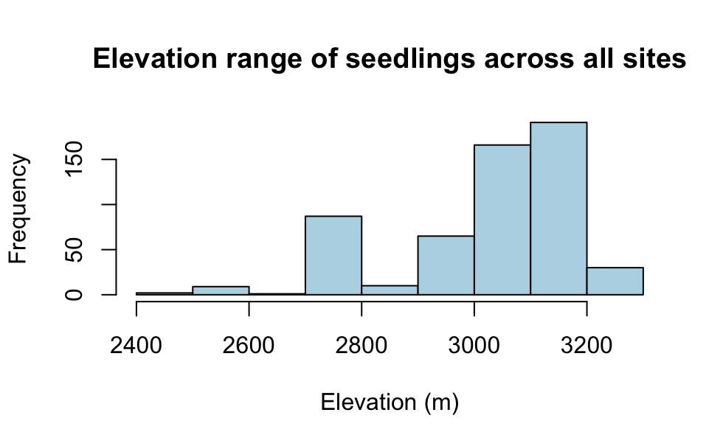

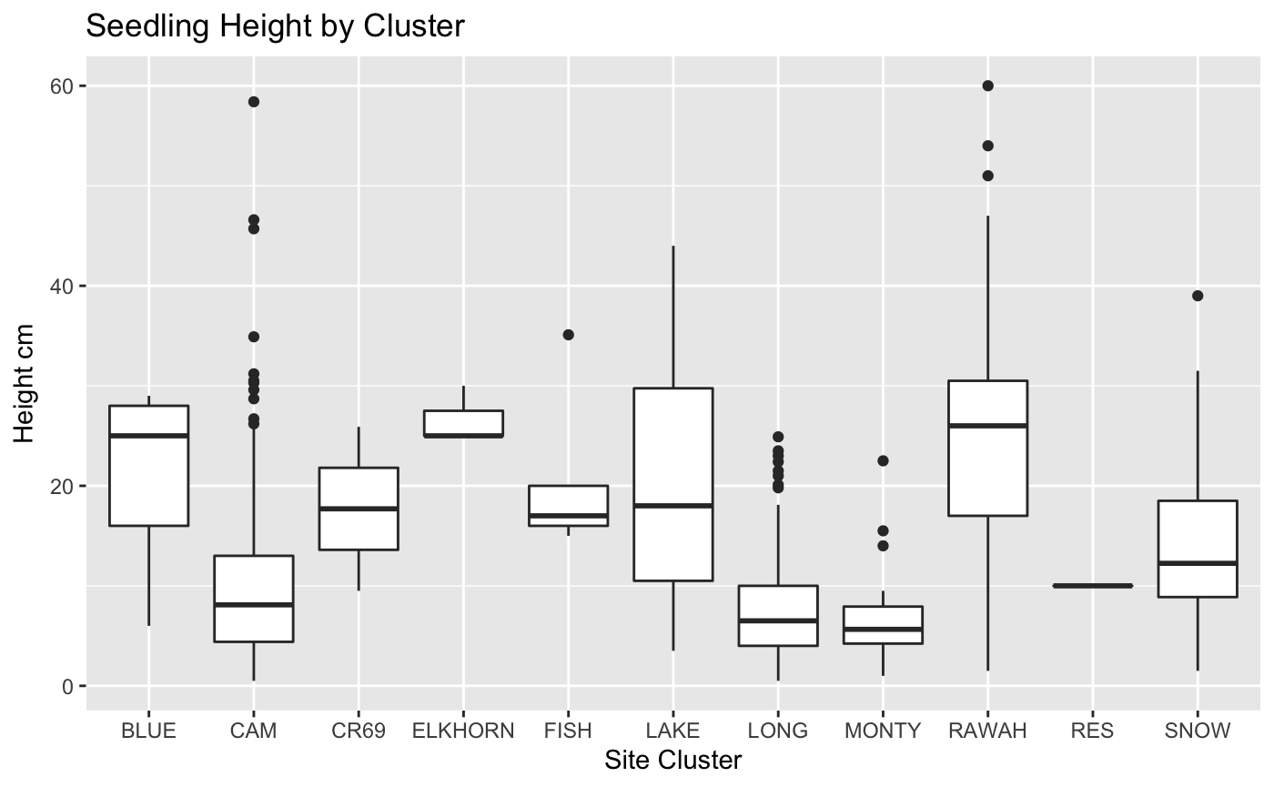

Figure S2. Distribution of seedling heights by cluster for all clusters.

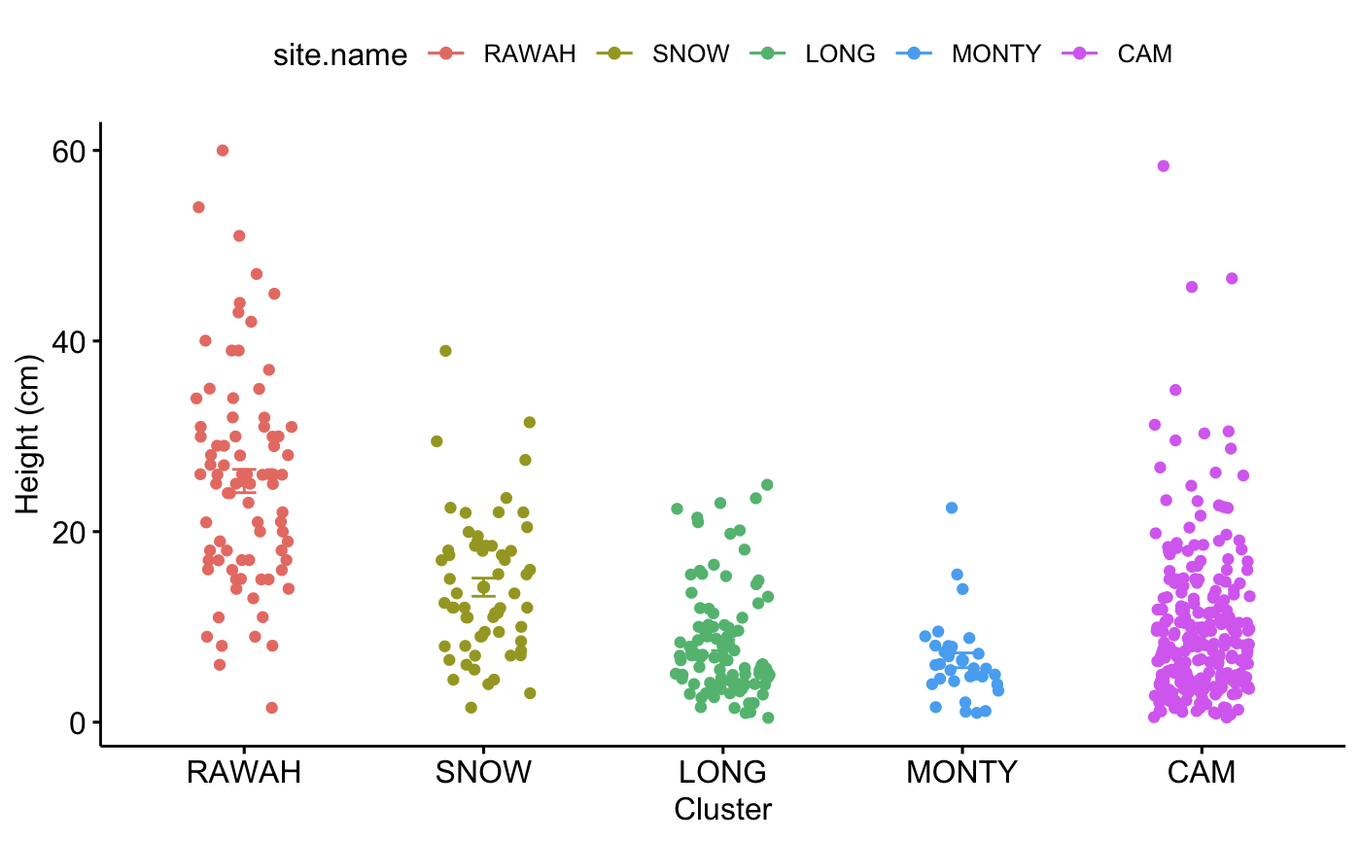

Figure S3. Distribution of seedling height for clusters containing > 10 seedlings as observed in 2022, (two years post-fire) at an elevation range of 2710 – 3259 m.

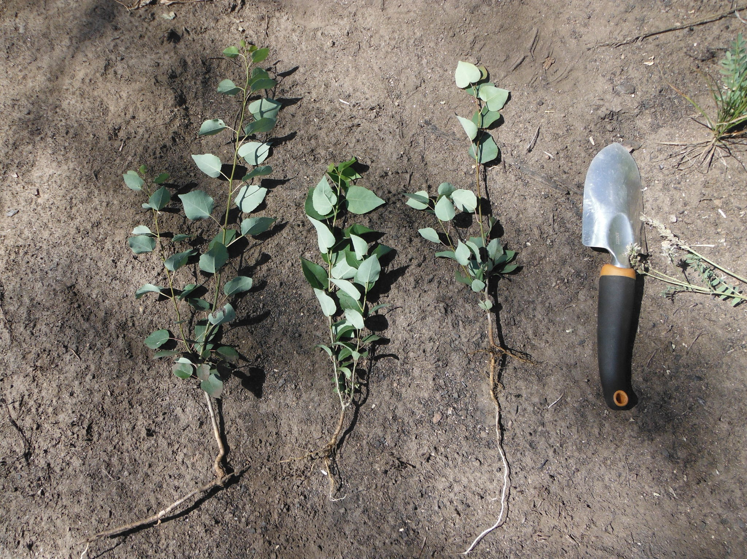

Figure S4. Comparison of fine root development of aspen seedlings (center, right) to root sucker connection to colony root system (left). All observed in 2022 (two years following fire) at approximately 2500 m.

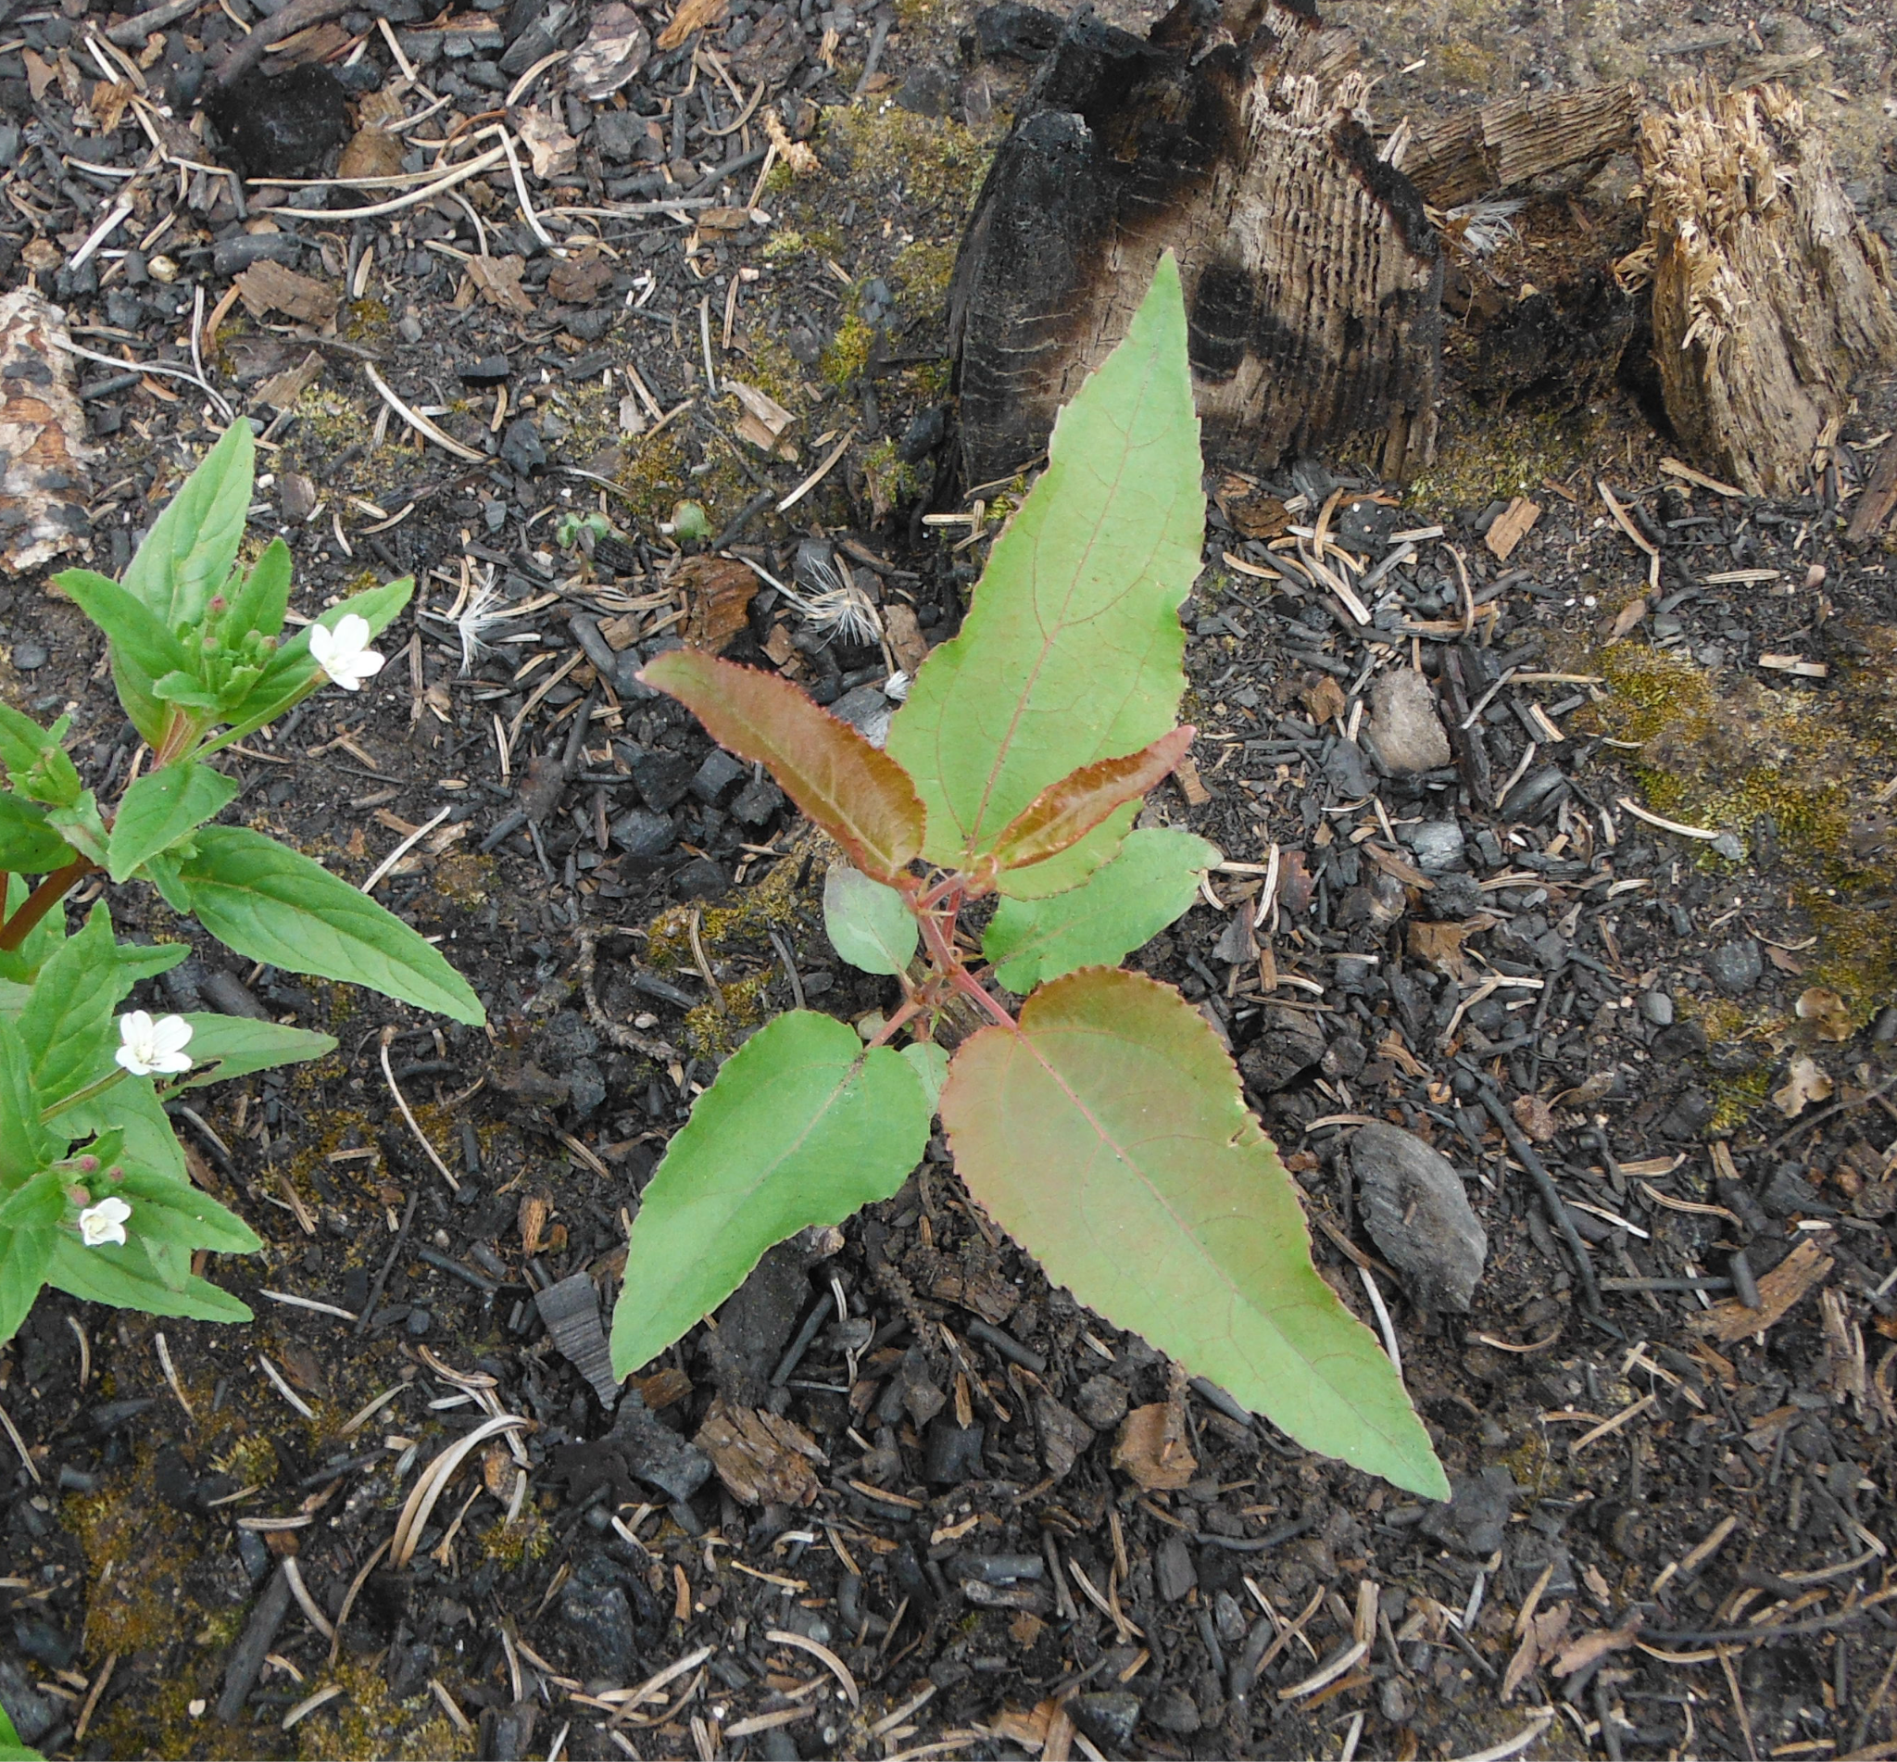

Figure S5. Aspen seedling with highly lanceolate leaves relative to typical morphology.

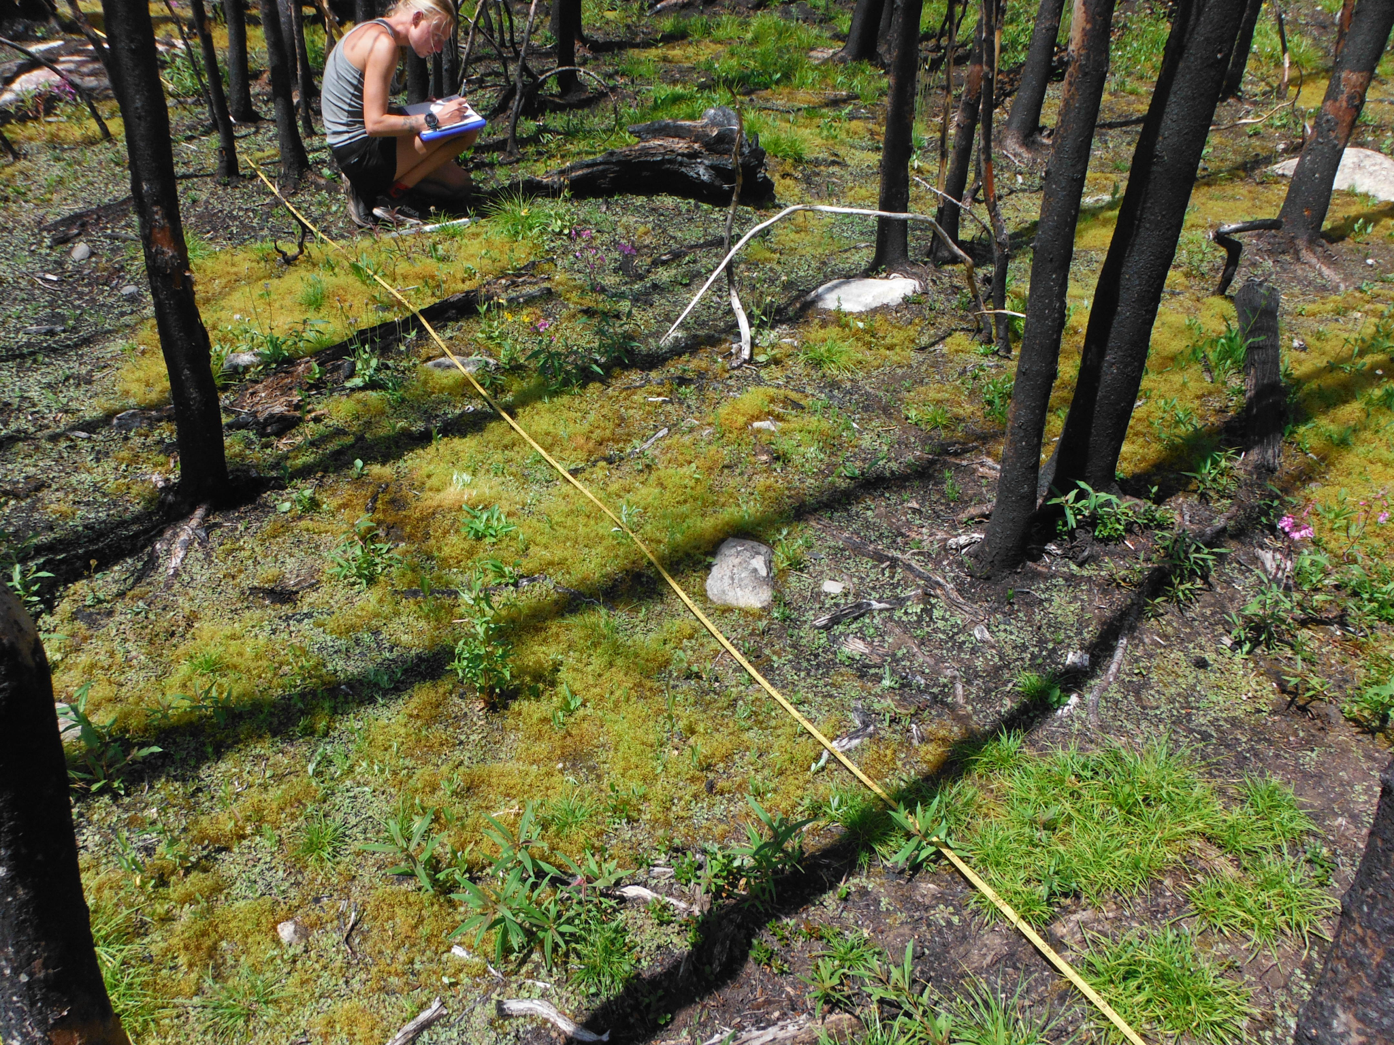

Figure S6. Localized riparian patch characterized by bryophyte substrate and above average vegetative cover, August 2022 (two years following fire), located at approximately 3100 m elevation (Long Draw Rd, near Cameron Pass, CO).

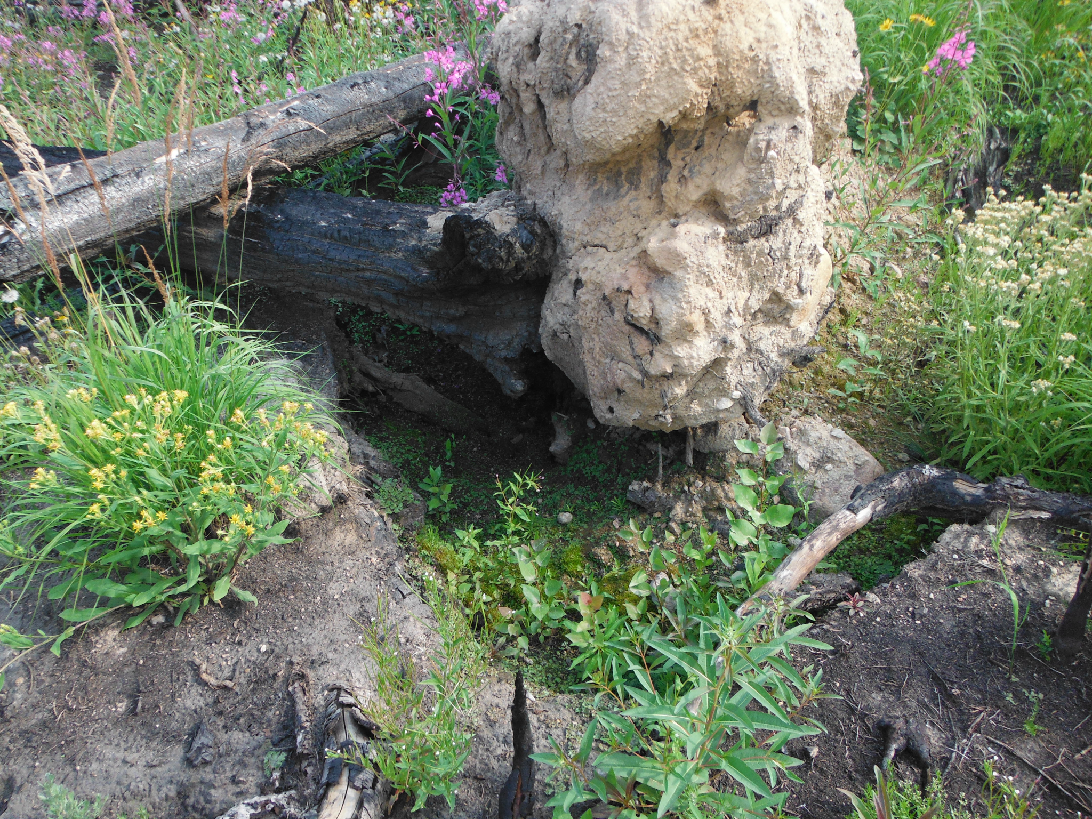

Figure S7. Fallen snag concavity favored by seedlings, indicator of seedling clustering.

## 